Copyright

By

Daniel Ware

2025

Tite Transformed: War and Counterinsurgency in Colonial Guinea

By

Daniel Ware

A Thesis Submitted to the Department of History
California State University, Bakersfield
In Partial Fulfillment for the Degree of Masters of History

Fall 2025

Tite Transformed: War and Counterinsurgency in Colonial Guinea

By Daniel Ware

This thesis or project has been accepted on behalf of the Department of History by his supervisory committee:

Dr. Mustafah Dhada
Professor
Committee Chair

Dr. Stephen Allen
Professor
Director, History Graduate Program

Dr. Moisés Acuña-Gurrola
Assistant Professor

Table of Contents

Abstract 1
Introduction 4
Chapter One 10
Chapter Two 21
Chapter Three 55
Chapter Four 80
Conclusion 105
Bibliography 113

Abstract
This thesis examines the transformation of the small colonial town of Tite, located in the Quinara region of Guinea-Bissau, during the eleven-year War of Independence (1963–1974). What began as a quiet outpost along the Geba Estuary became one of the most heavily fortified and symbolically charged sites of the conflict. Through an analysis of archival materials from Portugal and Guinea-Bissau, this study reveals how Tite served as both a microcosm of the broader colonial war and as a weapon wielded by both the Portuguese state and the Guinean PAIGC (Partido Africano para a Independência da Guiné e Cabo Verde, or African Party for the Independence of Guinea and Cape Verde). It argues that within Tite, the colonial and revolutionary forces simultaneously used space, propaganda, and human beings as instruments of control and resistance.
Tite’s importance was geographical as much as ideological. Situated between the Balanta heartland and the volatile southern frontier bordering the Republic of Guinea-Conakry, the outpost became a strategic hub for surveillance, supply routes, and political messaging. The Portuguese used it to monitor rebel crossings along the Geba River, while the PAIGC used its proximity to Conakry to coordinate cross-border incursions. Over time, Tite evolved from an agricultural settlement into a fortified, state-controlled resettlement village, or aldeamento. There, forced relocations, propaganda campaigns, imprisonment, torture, and military violence defined daily life. This transformation encapsulated the dual logic of Portugal’s colonial counterinsurgency: modernization through coercion and civilization through terror.
This argument takes the form of four distinct chapters. Chapter One traces the historical background that made Portuguese colonialism unique among its imperial peers. It also provides a brief context surrounding the creation of the rebellious PAIGC and the start of the revolutionary war.
Chapter Two examines the Portuguese policy of forced relocation and the construction of aldeamentos such as Tite. During the colonial war for the liberation of Guinea-Bissau, both the Portuguese and the PAIGC impacted local populations. Portugal did so as a deliberate counterinsurgent strategy while the PAIGC did so as an unintended consequence of its rural offensives. Both sides ultimately benefited from the control of these resettled populations.
Chapter Three explores Tite’s internal life under what this thesis terms a “dual sovereignty.” Portuguese administrative power came from the inside-out while PAIGC aggression and influence came from the outside-in. Both sides launched vigorous propaganda campaigns in Tite that sought to claim the hearts and minds of Guineans through coercion, promises, and fear.
Chapter Four exposes the human rights abuses that occurred within Tite, including arbitrary imprisonment, torture, and mass killing. These acts of repression prolonged a losing war for the Portuguese and gave the PAIGC powerful moral leverage in the international arena.
By tracing Tite’s wartime evolution from outpost to prison-village to symbol of colonial collapse, this thesis illuminates the human and spatial dimensions of counterinsurgency and wartime transformation. It contends that Tite was not merely a site of conflict but a microcosm of the entire colonial war. A place where modernity, violence, and propaganda converged, where an international independence movement was born and where a powerful, old-world empire breathed its last breaths.

Introduction
In 1962, a unit of Portuguese soldiers navigated the brackish waters of the Geba Estuary, traveling east through the middle of Guinea-Bissau in the heat and humidity. Dense mangrove thickets surrounded them, growing straight out of the calm water as sharp calls of West African herons and kingfishers cut through the motorized hum of the military boats. After docking along a muddy floodplain a few miles inland, they began to march southward. They crossed marsh and swampland, past flooded paddies and palm groves. The locals tending their farms regarded the soldiers with indifference; decades of colonial presence had numbed such scenes. After a few hours of hiking, the soldiers came to their destination: a remote colonial outpost called Tite.
The Portuguese secret police had summoned the battalion to Tite after receiving information that a rebel attack on the outpost was imminent. An organization known as the PAIGC (Partido Africano para a Independência da Guiné e Cabo Verde, or African Party for the Independence of Guinea and Cape Verde) was set on forcing the Portuguese out of West Africa. The PAIGC had recently transitioned from nonviolent protests to armed insurgency and the Portuguese colonial forces were taking no chances.
As soon as the reinforcements arrived, they began to put the locals to work, compelling them to quickly construct a fortified military garrison and a shielded perimeter. The soldiers made it clear that any resistance would be met with swift and severe punishment. They fortified Tite all year. When the Portuguese soldiers weren’t monitoring the labor inside the outpost, they were monitoring the dense forests and swamps outside. Tite slowly grew, waiting all year for an attack that was sure to come.
Then, in the early morning hours of January 23rd, 1963, PAIGC rebels crept upon Tite. They cut the telephone lines and power cables before beginning the assault in full. Though some rebels battled with automatic weapons and grenades, the majority only worked with machetes, sticks, and stones. The defenses the Portuguese had been readying all year were effective. After an hour of fighting, the rebel combatants retreated under heavy Portuguese fire.
Despite the initial Portuguese victory, this attack forced Portugal into a prolonged war with the PAIGC which lasted for the next eleven years, during which both sides destroyed dozens of villages as Portuguese napalm and white phosphorus rained down across the region. Colonial and rebel forces kidnapped, imprisoned, and killed countless people and subjected many of them to prolonged torture. Journalists described the Guinea-Bissau War of Independence as “Africa’s Vietnam.” Despite its costs, the war managed to unite a vast array of distinct ethnic groups under a common banner. It resulted in the successful expulsion of Portuguese colonialism and the birth of the free and independent Guinea-Bissau. And it was a war that didn’t begin in the bustling, politically active capital city of Bissau. It began in the small, quiet, colonial town of Tite.
Over the next eleven years, Tite underwent continuous assault by the PAIGC but never fell to them. The Portuguese defended and maintained it until they withdrew from the region in 1974. During the war, Lisbon sent continuous military reinforcements to Tite. Tite also housed active construction projects and new technological and agricultural developments. It was even among the initial testing grounds for Portugal’s use of helicopters during the war.
There are several reasons Tite was so important to both the Portuguese and to the PAIGC. The first is its proximity to the Republic of Guinea-Conakry, the neighboring country to the south. In the early years of the war, the PAIGC operated out of Conakry for reasons of security and safety, and to maintain close diplomatic, military, and financial ties to their southern allies. As a result, Guinea-Bissau’s southern border was among the most volatile fronts of the war, and Tite, situated directly within this contested region, became a critical outpost for monitoring cross-border movement and defending the frontier.
Second, immediately to the north of Tite ran the Geba Estuary. This waterway was as important as the southern border, if not more so. Control of the Geba was essential for maintaining international supply lines. Portugal depended on it to transport troops and materials from Europe, while the PAIGC relied on it to carry weapons and aid from its foreign allies into the interior. Whoever controlled the Geba controlled the flow of the war.
Finally, Tite stood at the center of the Balanta heartland. The Balanta were Guinea-Bissau’s largest ethnic group and a decisive demographic in the conflict. Both the Portuguese and the PAIGC launched extensive propaganda campaigns aimed at winning Balanta loyalty. Swaying the Balantas one way or another could tip the balance of the entire southern front.
Yet the primary reason Tite is the focus of this thesis is not because of its strategic geography, but because Tite in the war years serves as a nearly perfect microcosm of the Guinea-Bissau War of Independence itself. The war was defined by two interlocking struggles: population control and insurgency/counterinsurgency. These forces shaped every aspect of the conflict, both for the colonial Portuguese and the rebelling PAIGC. These two aspects also thoroughly transformed the lives of Guineans and the local structures of their environments. Nowhere were these two forces more visible, more intimate, or more transformative than in Tite.
Tite was a unique combination of a native village, colonial military base, prison, concentration camp, battlefield, agricultural center, business plaza, and a logistical crossroads for traffic between Guinea-Bissau and the Republic of Guinea-Conakry. By approaching the war through a microhistory of Tite rather than a macrohistory of the entire colony, this thesis makes it possible to recover the texture of lived experience. Details of daily life tend to get smoothed over in larger narratives for the sake of grand political narratives. Through Tite’s story, one can still see the grand narrative, just in miniature: a place where empire and revolution, propaganda and violence, coercion and survival all collided within one small area. One also sees how the war transformed local spaces and how spatial transformation changed Guinean lives.
This thesis argues that Tite functioned as a weapon simultaneously wielded by both Portugal and the PAIGC. Through forced relocation, siege, propaganda, imprisonment, torture, murder, and international exposure, both sides of the conflict treated Guinean civilians not only as hearts and minds to be persuaded and won, but as physical commodities to be moved, contained, displayed, and sacrificed in the interest of winning the war.
The following chapters were written after a research trip to Guinea-Bissau I took between April and June of 2025. I was accompanied and advised by Dr. Mustafah Dhada, an oral and forensic historian specializing in Lusophone Africa. During the trip, we accessed and digitized archival documents from the Instituto Nacional de Estudos e Pesquisa, or National Institute for Studies and Research (INEP) in Bissau.
We originally planned to visit Tite, where historical and anthropological field work could be performed. Unfortunately, bureaucratic issues prevented us from doing so. Fortunately, further documents, previously digitized from three different Portuguese archives, were made available for research. These archives include Lisbon’s Arquivo Nacional da Torre do Tombo, or National Archive of the Tower of Tombo (ANTT), Arquivo da Defesa Nacional, or National Defense Archive, and Arquivo Histórico Militar, or Military History Archive (AHM). While non-colonial source material for this thesis is lacking, further field work and research in Tite itself is currently being planned.

Chapter One
To understand Tite’s role in the war and the transformation it underwent, this thesis first places it within the broader history of Portuguese colonialism in West Africa. In the mid-1400s, the budding Portuguese empire began exploring southward along Africa’s Atlantic coast. Early on, they attempted a land invasion of Morocco but failed disastrously. This formative defeat inspired Portugal to focus on building forts along the African coast, from which they could exercise economic influence and control. They halted further militaristic attempts to move inward.
After failing in Morocco, Portugal turned its gaze toward the West African archipelagos of São Tomé and Príncipe as well as Cape Verde. They also began exploring the various rivers leading into the continent from the Atlantic. Portugal, for much of its early colonial history in Africa, remained hesitant to venture too far inland. They opted instead to establish profitable trading posts throughout Africa's coasts and western waterways. At first, they dealt in gold and ivory. Later, Portugal’s established sea presence meant they profited greatly from the Atlantic slave trade starting in the mid-1500s.
Portugal maintained major slave-trading ports throughout Africa’s west coast through the 16th to 19th centuries. They also expanded across the Atlantic and set up plantations and slaving hubs in South America. They used this presence to form the Governo-Geral do Brasil, or Governorate General of Brazil.
Brazil declared independence from Portugal in 1822. Soon after, former slave-trading nations abolished and dismantled the Atlantic slave trade in various stages. Portugal had to quickly scramble to redefine its identity in terms of empire and international role. Africa was central to that new identity. The Portuguese had ambitious visions of empire. They wanted to connect Angola in the east to Mozambique in the west, creating a purely Portuguese interior across southern Africa. However, Portugal found itself outmaneuvered by other European nations with similar ideas. They lost out in the Berlin Conference of 1884-1885 and were further undercut by the British Ultimatum of 1890. They ended up with the coastal presence they had had all along. They kept the colonies of Angola, Mozambique, Guinea-Bissau, Cape Verde, and São Tomé and Príncipe, a far cry from their original ambitions.
Portugal had clear imperial dreams but was unable to make them a reality. Portugal often lost out to other European powers, namely Britain. According to historian Valentim Alexandre, Portugal had a bipolar narrative of history. It saw itself as a nation chosen by God to discover, evangelize, and civilize the heathen world. But at the same time, it saw itself as a vulnerable country perpetually victimized and abused by larger European powers.
This bipolar narrative gave Portugal a unique form of colonial rule over its African holdings. In 1932, António de Oliveira Salazar took over as prime minister. He established the Estado Novo, or New State, which featured repression, censorship, detainment, and propaganda. This New State also redefined Portugal’s colonizing mission in front of the United Nations. They called it “Lusotropicalism.” Lusotropicalism was a theory Brazilian sociologist Gilberto Freyre promoted that claimed the Portuguese had a unique aptitude for harmonious racial mixing and cultural adaptation among their tropical colonies, which made it better suited for colonial endeavors than its European peers.
The realities of Lusotropicalism in Guinea-Bissau, however, were less harmonious. Portuguese colonial administrators often forced harsh agricultural labor, even among children. Colonial authorities beat and flogged those who did not meet their extreme and arbitrary quotas. Quotas became even more difficult to meet because white settlers received the most fertile land. Native Guineans were often displaced in the process. Though Portugal preached ethnic blending, the black and white divide was strong. Individuals rarely reached the assimilado, or assimilated, status. Besides meeting agricultural quotas, Guineans also had to spend a fixed amount of time on public infrastructure. Roads, bridges, and other public works had to be built and maintained through local labor.
Taxes were unreasonable and arbitrary. Locals often had to pay taxes for their long-deceased parents or grandparents. Those who could not pay taxes were punished with the palmatória—a heavy wooden block used to crush a victim’s hands. Villages under Portuguese control also had to volunteer a certain number of native men for conscription by the colonial military each year.
The largest ethnic group in Guinea-Bissau, the Balanta, practiced a sacred age-grade ritual in which youths coming of age must take part in a raid against a neighboring village. These raids, while much more violent in the past, usually just involved the theft of cattle and other relatively harmless feats by the 20th century. The Portuguese banned this important ritual, claiming it upset economic operations. Festivals, drumming, and dancing were also important to Balanta populations. These were heavily regulated or outright banned by Portuguese authorities for the noise they caused. The colonial authorities delivered harsh fines and beatings upon disobedience of these ordinances.
The second largest ethnic group in Guinea-Bissau was the Fula, overwhelmingly pious and devout Muslims. The Portuguese often punished Fulas by forcing them to eat pork and drink wine, going against their faith and resulting in a deep lifelong humiliation. There was also a mitanco, or a tax simply for having a beard, which seemed to specifically target Muslim Fula men.
Under Portuguese rule, there was a 99% illiteracy rate in Guinea-Bissau. There were only two hospitals for nearly a million inhabitants. Women suffered sexual violence, harassment, and disproportionate rates of imprisonment. Brutal penal systems in Bissau, Tarrafal, Ilha do Sal, Ilha das Galinhas, and, as will be explored further, Tite, confined those who opposed Portuguese colonialism. An article from Afrique Nouvelle, an Africa-centered publication from France, criticized Portugal's colonial regime as the most totalitarian and draconian of all European colonialisms.
The people of Guinea-Bissau could only take so much. Despite the looming threat of violence, deportation, and imprisonment, various anti-colonial political groups sprang up in the mid-1900s. The Movimento de Libertação da Guiné, or the Guinea Liberation Movement, was one. The União dos Naturais da Guiné Portuguesa, or the Union of Natives of Portuguese Guinea, was another. At least half a dozen similarly named independence movements cropped up in the 1950s and ‘60s. Most of them were fleeting and achieved little success. One movement, however, stood above the rest for its superior organization and leadership: the Partido Africano para a Independência da Guiné e Cabo Verde, or the African Party for the Independence of Guinea and Cape Verde (PAIGC).
The PAIGC was founded and led by Amílcar Cabral (alongside Aristides Pereira, Luís Cabral, Fernando Fortes, Elisée Turpin, and Júlio de Almeida). Cabral was not raised in Guinea-Bissau but in the Cape Verde islands to the west which were also under Portuguese rule. Cabral saw Cape Verdeans and Guineans as unified comrades in a singular shared struggle against Portugal.
Upon its formation in Bissau in 1956, the PAIGC was strictly a group of peaceful political activists. They operated secretly in their early years, mobilizing the peasantry to political action both in Bissau and in rural areas. When quiet political action failed to affect change in Portugal’s oppressive system, Cabral and the PAIGC moved from clandestine meetings to public strikes and protests, the most infamous of which came in 1959 on the Pidjiguiti docks in Bissau.
The PAIGC organized the strike to negotiate better pay and treatment for native dockworkers. The strike was peaceful, but the police forcefully disrupted the protest anyway. The workers responded to the pressure by barricading themselves away, some taking up oars and harpoons to defend themselves. This was enough for the police, who opened fire on the dense crowd, killing dozens of dockworkers outright. Some workers attempted to jump off the dock or escape in boats but were shot dead in the water. The Portuguese police even threw grenades into the middle of the barricaded crowd. Official estimates of the death toll vary. Portuguese police reports suggest twenty, while the PAIGC claims fifty.
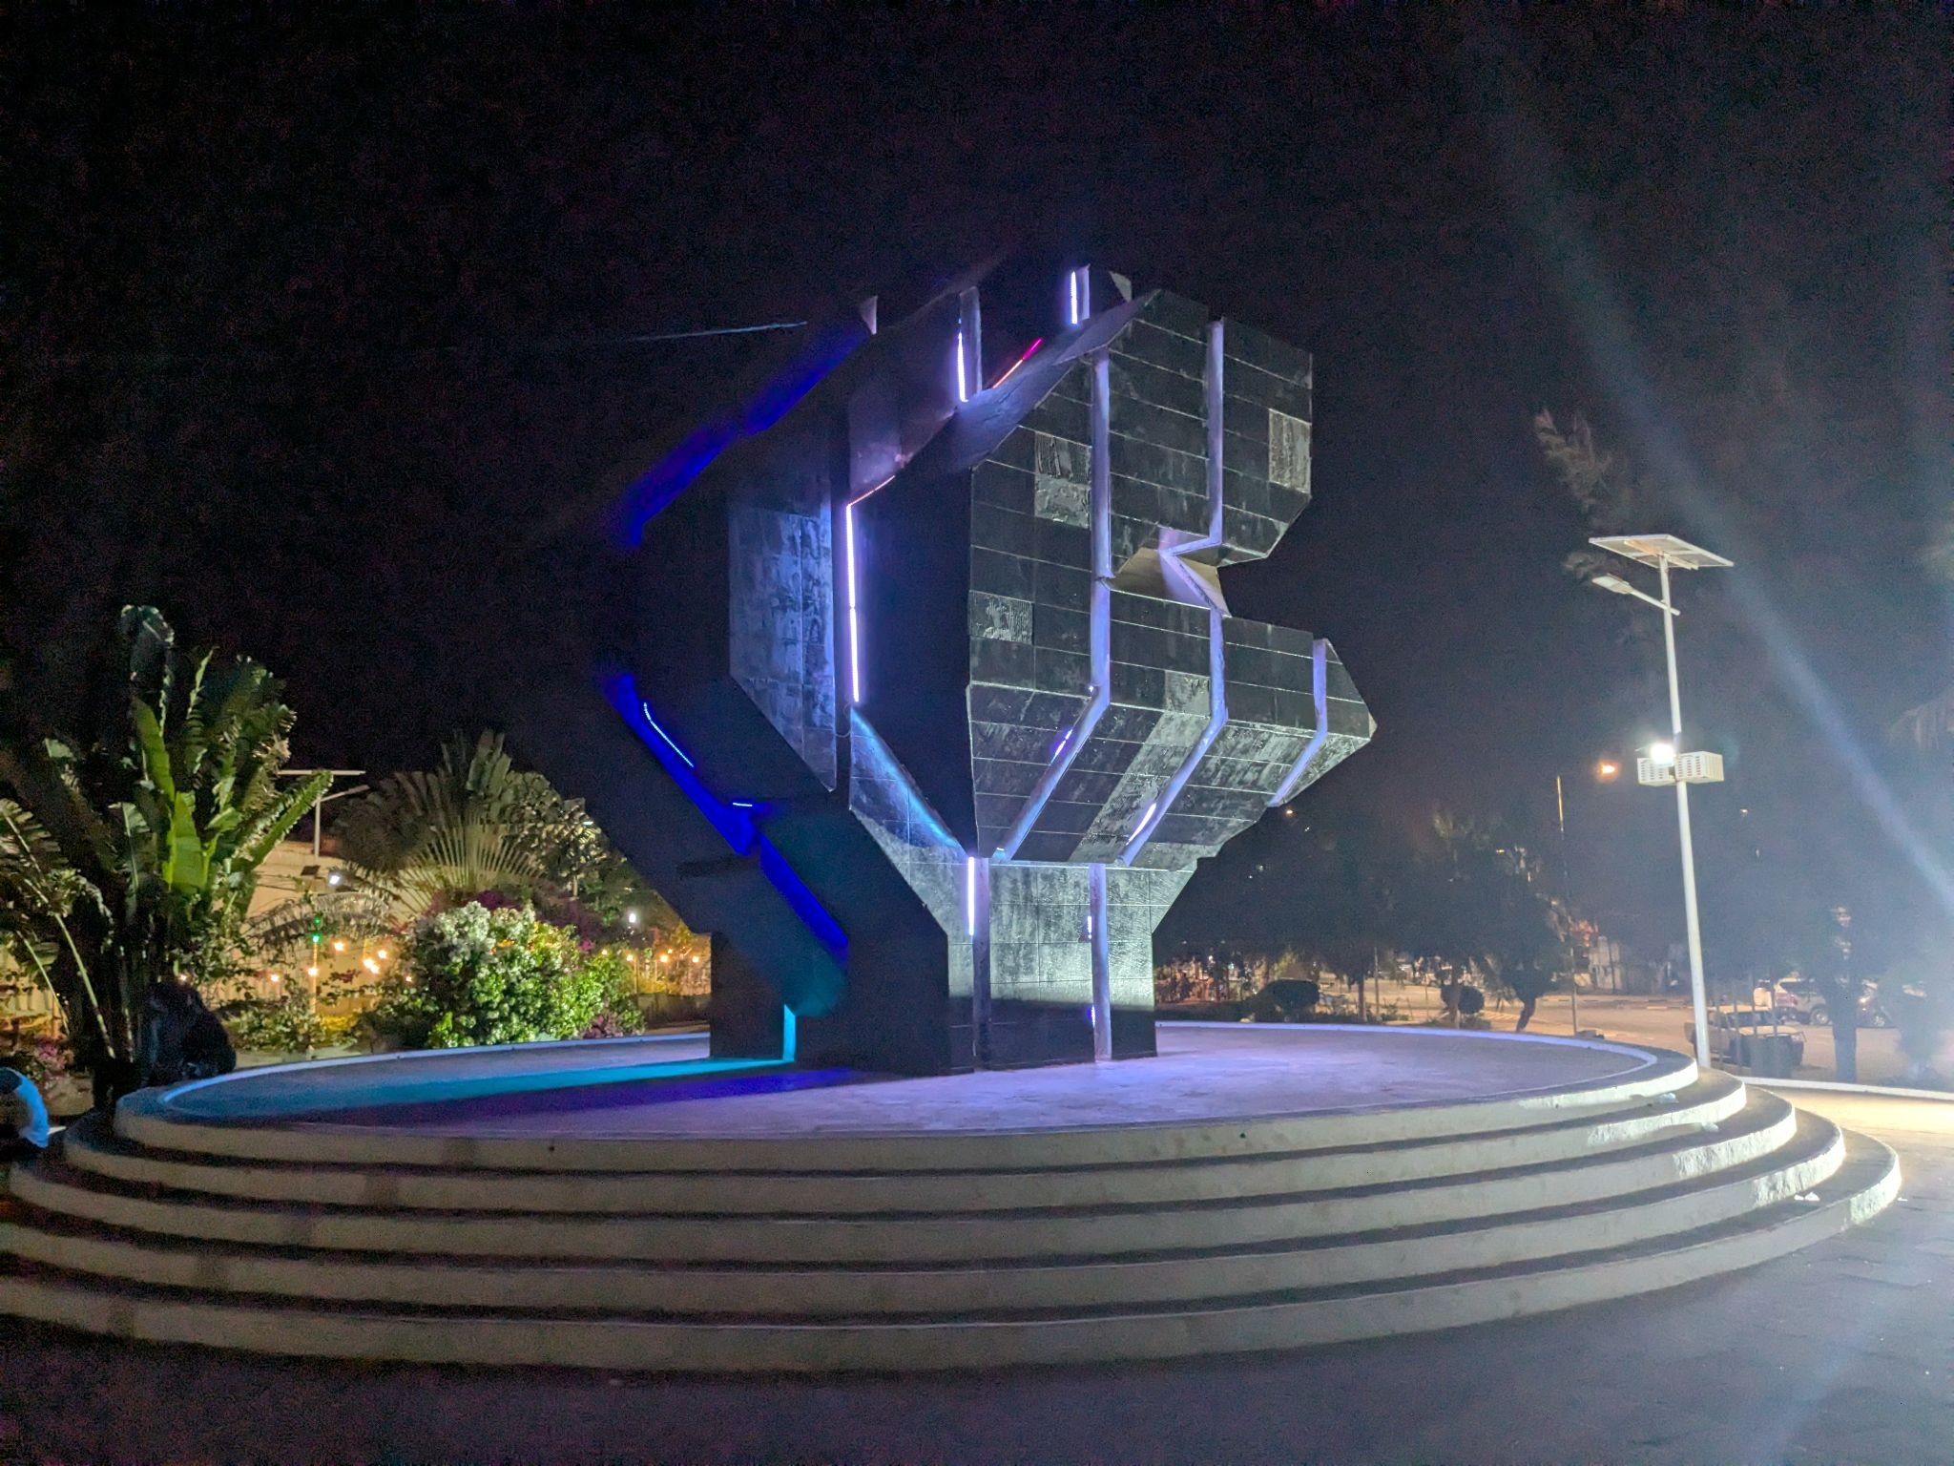
Figure 1. Pidjiguiti Massacre memorial, Bissau, May 2025. Photograph by the author. © 2025 Daniel Ware.

The Pidjiguiti Massacre is often cited as the tipping point for the PAIGC. The point where they realized that peaceful political activity and protests, no matter how fervent, would not affect change in Portugal’s brutal colonial system. After the massacre, the PAIGC transitioned from peaceful political activists to militaristic freedom fighters. Clandestine meetings turned to open revolt, and the PAIGC would spend the next four years preparing for open war. They were immediately more effective at swaying public opinion in the rural parts of the country than the Portuguese were. They set up village committees, schools, stores, and clinics all over the countryside. This investment into infrastructure would play a crucial role in the PAIGC’s eventual victory.
The PAIGC also established an early relationship with both the Soviet Union and China. These communist nations had interests both in anti-colonialism and in undermining Western European global influence. From them, the PAIGC was able to secure significant amounts of weapons as well as training for its fighters between the years of 1960 and 1963. In only a few years, the PAIGC had transitioned from a secretive group of political activists to a capable militia controlling half the countryside. They had arms, training, and international backing. By 1963, the PAIGC was ready to take down the Portuguese colonial regime.
And the site chosen to begin this international revolt was Tite—the small agricultural colonial outpost in the rural south. Up until this point, Tite was hardly a dot on Portuguese maps. The history of Tite prior to 1963 is difficult to trace since pre-war historical records of the outpost are slim to nonexistent. Portugal did not embrace the interior of Guinea-Bissau until 1915. Financial records of Tite are in a Portuguese colonial administrative manifest from as early as 1947. It is likely that Tite became an official colonial outpost earlier, around the 1915 inward expansion. Once the war started, Tite would be immediately transformed from an obscure outpost to a major center of war.
In the eleven years between the first shots of the war and the achievement of independence, Tite remained one of the most important and contested sites in Guinea-Bissau. Over the next three chapters, this thesis traces the town’s strategic, political, and symbolic significance through the forced relocation of its citizens, the physical and psychological battles for their allegiance, and the tortures and murders that occurred within Tite’s barbed wire perimeter.

Chapter Two
Portugal’s colonial ideology that made forced relocation not only possible but framed as benevolent humanitarianism was called Lusotropicalism. Lusotropicalism was a sociological theory that taught that through miscegenation and cultural blending, Portugal could create a unique and harmonious colonial society; one that was peaceful, ethical, and superior to the oppressive colonial regimes of Britain and France. Lusotropicalism even suggested that Portugal could be a pluricontinental, multilingual, and multicultural nation. Portugal stopped using the word “colony” altogether and reframed their holdings as “overseas provinces,” an integrated extension of Portugal itself. In practice, this was a framework for political rule, not a description of social fact.
This new state doctrine was exemplified in a 1934 propaganda map drawn by Portuguese army officer and writer Henrique Galvão. In it, Portugal’s African holdings (Guinea-Bissau, Mozambique, and Angola) are overlaid across Europe, taking over much of Spain, France, and Eastern Europe. In the corner of the map is the phrase “Portugal não é um país pequeno,” or “Portugal is not a small country.” The map boldly asserts Portugal’s cohesion and imperial strength while also revealing an anxiety and insecurity about its place among the European powers.
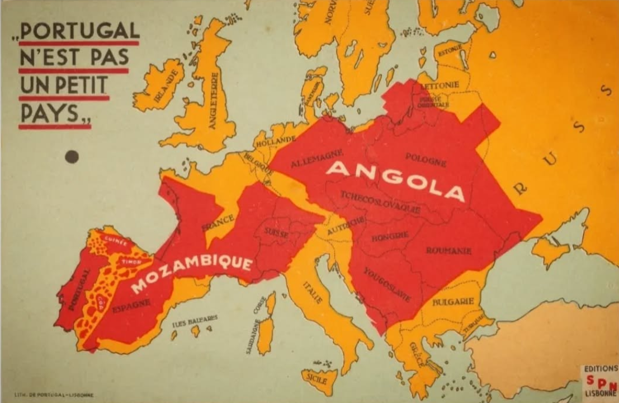
Figure 2. Portugal n’est pas un petit pays (“Portugal is not a small country”), propaganda map designed by Henrique Galvão, 1934. © Biblioteca Nacional de Portugal.

Part of the motivation behind the adoption of Lusotropicalism is that Portugal had an insecurity over how small the country was when compared to other modern, industrial European powers. Portugal wanted, in a sense, to prove to the world that it could do colonialism “better” than the other colonial empires. Lusotropicalism was its strategy to do so.
In Guinea-Bissau, Lusotropicalism got defined even further. The concept “supervisão total,” or “closed supervision,” was expressly defined in official colonial documents. Closed supervision was a system where certain African populations received significant financial and technical support if they agreed to assimilate to the Portuguese way of life. This was a way for Portugal to compel native Africans to adapt to Portuguese living, rather than the other way around, like Lusotropicalism purported to allow for. It also monopolized the market and streamlined Portuguese profits. It required African laborers to give up their rights to sell products and negotiate markets on their own. Lusotropicalism was an abstract global agenda used among the international public. Closed supervision was a practical, in-the-field method of maintaining colonies.
With the closed supervision process in place, native populations in Guinea-Bissau who did not take part were then identified and subjected to abuse. Those who did comply were subject to economic exploitation. Colonial authorities often removed the closed supervision benefits on a whim. Portugal claimed that its Lusotropicalist brand of empire was less abusive than their imperial counterparts but in reality it was as vicious and cruel, if not more so. By the time the war began in 1963, the colony was fully under Portugal’s closed supervision policy.
Arnaldo Schulz was the colonial governor of Guinea-Bissau during the early years of the war, specifically 1964 to 1968. His war tactics were heavy-handed, militaristic, and straightforward. He fortified military garrisons, bombed villages, and utilized deadly napalm attacks. Schulz, in his tenure in Guinea-Bissau, endorsed a simple “search-and-destroy” phase of the war. He placed heavy emphasis on offensive sweeps, air power, and large territorial control to find and destroy PAIGC bases. This approach struggled in Guinea-Bissau’s marshy terrain and the PAIGC was able to quickly adapt to Schulz’s straightforward tactics. They mobilized their units and adopted anti-aircraft weaponry. Not long after, Schulz was recalled and Lisbon sought alternative leadership in Guinea-Bissau.
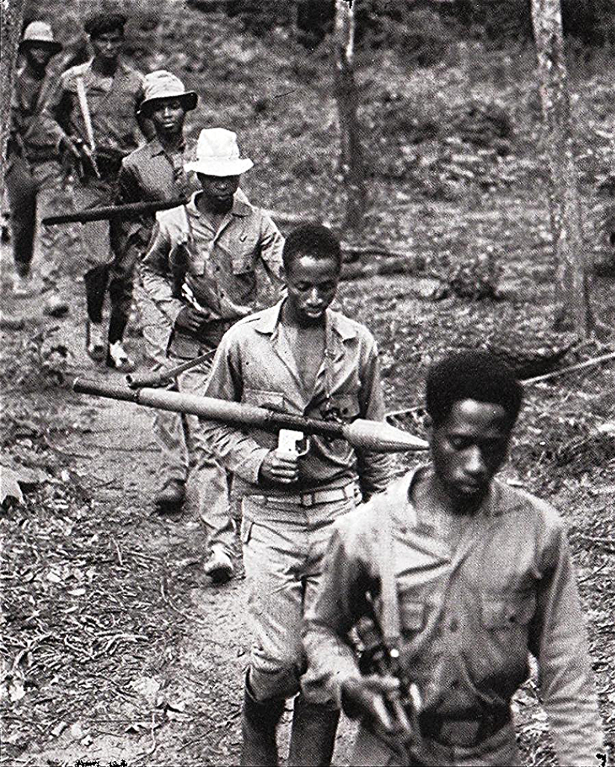
Figure 3. PAIGC guerrillas on the move in the bush, Guinea-Bissau, undated. PAIGC photograph. Reproduced in Mikael Levin – Cristina’s History (Cherbourg-Octeville: Le Point du Jour; Lisbon: Museu Colecção Berardo, 2009), 91. © PAIGC (via Luís Graça & Camaradas da Guiné blog, March 16, 2010).

His replacement, António de Spínola, changed things. Spínola ruled as governor of Guinea-Bissau from 1968 until just before the end of the war in 1973. His strategies were no less violent than Schulz’s, as Guinean villages continued to burn, but Spínola embraced new tactics as well. While Schulz emphasized a “search-and-destroy” tactic, António de Spínola embraced a “hearts and minds” tactic. Amílcar Cabral, leader of the PAIGC, referred to this as a “soft” tactic. It included building schools, churches, mosques, and clinics. Bright African students were given scholarships and free trips to Portugal. Guineans, in theory, received a better quality of life under Spínola’s hearts and minds campaign. Spínola launched this campaign designed to win the public opinion of local Guineans. The campaign was officially titled Uma Guiné Melhor, or A Better Guinea.
To Spínola, winning the hearts and minds of local populations was key to winning the war. He launched massive propaganda campaigns, appealing directly to the various ethnic groups in Guinea-Bissau. Flyers dropped continuously from helicopters and airplanes. Pro-Portuguese film screenings occurred throughout the countryside. There was a significant increase in newspapers and radio stations that painted the Portuguese in a positive light. Local leaders received bribes of money, tobacco, and other goods. Spínola put Portugal’s humanitarian, reformist ideals in the foreground, while still keeping deadly counterinsurgent military activities going in the background. These tactics, as will be seen in Chapter Three, were extremely effective and helped to prolong the war.
Militarily though, the PAIGC surprised the Portuguese with their strength and capability. They used mobile, guerrilla warfare to great effect. The PAIGC fighters were so effective the Portuguese quickly had to update their ground tactics. The Portuguese were consistently caught off guard by the mines and traps the PAIGC regularly laid and the rebel fighters’ advanced knowledge of the interior allowed them to manipulate it to great, and creative, effect. On one occasion in particular, rebel troops used swarms of killer bees as an ambush tactic against a Portuguese battalion. In 1967, historian Gérard Chaliand who was in the field with the PAIGC wrote that for “the Portuguese, the war is already lost.” Writing in 1968, Spínola himself would say that most Portuguese military operations in Guinea-Bissau were failing. Spínola needed to make drastic changes.
And make changes he did. After their early ground encounters, Spínola limited Portuguese foot patrols. He opted instead for air strikes, naval operations, and long-term garrison-based defense. The Portuguese hunkered down in fortified military garrisons and let their superior war machines do the work. They only engaged in ground fighting when necessary. It was a long-term strategy, designed to use Portugal’s perceived superiority in logistics, supply, and international relations to wait the rebels out. Spínola endorsed this strategy, but realized it was not going to win the war overnight. Shortly after taking over as governor of the colony, he instituted one last “hearts and minds” tactic: forced relocation.
The forcible relocation of citizens by a foreign power for militaristic, political, religious, or economic gain is a strategy dating back hundreds of years. It has seen use all over the globe, with perhaps its first large-scale example coming in South America in the 1500s. There, in what is now modern-day Brazil, colonial Spanish and Portuguese administrators resettled indigenous, nomadic populations in a sweeping evangelization effort. The United States had similar programs in the 1800s, forcing Native Americans out of their homes and into state-designated reservations under the guise of compassion, civilization, and modernity. Australian Aborigines were forcibly relocated to Flinders Island. The Spanish relocated Cubans during their independence war, as did the United States to Filipinos during their liberation movement. The first use of the term “concentration camp” came by way of the British during the Boer wars which laid the groundwork for the large-scale Nazi camps that spread throughout Europe during World War II.
However, the type of forced relocation the Portuguese introduced during the war in Guinea-Bissau most resembled the strategic villages the French utilized in Algeria in the 1950s. The French utilized this clear counterinsurgency tactic to control and pacify rebellious Algerian communities. Like the Portuguese would later do, the French reframed their forced relocations. They obfuscated the true reasoning behind the program. “The objective was to instill in the Algerian populations the idea that the colonial government was acting on the level of territorial planning and not on a strictly military vision.”
Portuguese colonial officers “systematically studied” the failures and successes of the French relocation program in Algeria. Some members of the Portuguese military even went to France specifically to study French counterinsurgency tactics in Algeria. “Anticipating the war in Africa, the mission brought the Portuguese military forces into contact with the insurgency and guerrilla tactics deployed by the Front de Libération Nationale and the counterinsurgency methods used by the French army to prevent its progression.”
Portugal was already interested in relocation tactics at this time. In 1946, then colonial governor of Guinea-Bissau, Sarmento Rodrigues, instituted the “Indigenous Urbanization Plan.” This was designed to further assimilate native Africans to the Portuguese way of life. Similar efforts were made in the 1950s. These early attempts at state-controlled habitation sites were limited in scope and focused on only a few settler strongholds rather than the native hinterlands. Due to their small scale and limited scope, most native Guineans continued to live in traditional houses and villages. This initial form of relocation in the 1950s and early 1960s was more about Lusotropicalist ideals of promotion and assimilation than it was about counterinsurgency or militaristic population control.
It wasn’t until the Portuguese began studying French relocation in Algeria that they realized how effective state-sponsored forced relocation programs could be in the context of changing the tides of a guerrilla war. The idea that “intimate contact with the populations” should be central to counterinsurgency in Guinea-Bissau came directly from Algeria. This was the mindset Spínola had when he took over as the colonial governor in 1968.
Portugal’s official forced relocation policy in Guinea-Bissau involved convincing, compelling, or otherwise forcing local populations out of their natural villages and into artificial, state-controlled villages. These artificial, state-controlled villages were known as aldeamentos, or resettlement villages. While the Portuguese tended to frame these movements as voluntary, most of the time they were not. Portuguese soldiers regularly burned and bombed villages and forcibly stole their populations away to state-controlled aldeamentos. Portuguese commanders explicitly instructed soldiers to “collect” populations in various villages. These same villages were often burned and destroyed. Interestingly, instructions were also sometimes given to keep certain villages and populations undisturbed, though such instructions were rare.
Forced relocation and the use of aldeamentos was not limited to Guinea-Bissau. The Portuguese practiced it on a much larger scale in their other African colonies of Angola and Mozambique. Over a million people were displaced in each of the two countries. In Guinea-Bissau, by far the smallest of three, around 150,000 people were displaced.
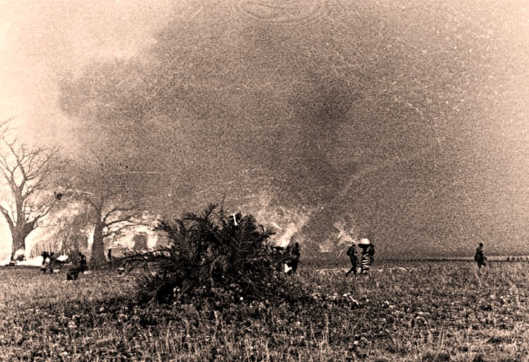
Figure 4. Bissássema, Tite region, 10 March 1968 — destruction of the village by Portuguese troops (CCAÇ 2314). © Luís Graça & Camaradas da Guiné Blog, 30 May 2025. https://blogueforanadaevaotres.blogspot.com/2025/05/guine-6174-p26863-casos-verdade-sobre.html
Though the Portuguese utilized violence and force to resettle populations most of the time, they still attempted to convince and persuade populations to resettle voluntarily. They spread the message that in the Portuguese aldeamentos, Guineans would be safer and better off. They’d have better living conditions, better schools, and access to clean water and medicine. The Portuguese also tailored their message to individual ethnic groups. To the Fulas and Mandinkas, the message was that the Portuguese aldeamentos had mosques, where they could practice Islam in peace. The Balantas and Manjacos were told that in the Portuguese aldeamentos their rice fields and cattle would be protected and their traditional customs respected. They also emphasized the malevolence of the PAIGC. The Portuguese regularly framed rebel fighters as terrorists and convinced native populations that they were worse off in PAIGC hands. The Portuguese reduced their propaganda campaign to one simple slogan: “Connosco o céu, com o inimigo o inferno”, or "With us Heaven, with the enemy Hell.”
The Portuguese built their aldeamentos around their fortified military garrisons. They were built in intentional grid-like patterns with barbed-wire perimeters, with an architectural style often in facsimile of the locals’ former villages. The grids allowed for wide streets and empty space for trees. The buildings were usually constructed of adobe walls and thatch or zinc roofing. Buildings for the soldiers like barracks and mess halls were easily distinguishable from residential buildings for locals. Colonial buildings were long and rectangular, constructed of sturdier materials like concrete and metal. The buildings in which locals lived were square and constructed of more natural materials like adobe or reeds. The blocks for these structures typically measured 0.20 × 0.20 × 0.40 meters and were relatively quick to build, requiring the adobe to dry in the sun for only two days. The habitation structures did not contain bathrooms, despite the Portuguese insistence on sanitation.
Aldeamentos were cheap, quick to build, and effective. Later attempts at making habitation structures for locals more comfortable and hygienic failed because they were too costly and required too much labor. Aldeamentos were designed to be transient, temporary, and functional. They were military tools. They “succeeded in what was intended: rapidly built, large numbers of units; strategically grouped and controlled populations. The military was thus able to create a landscape in its own image: geometrized, zoned, and resilient.”
Platoons of Portuguese military engineers first came to Guinea-Bissau shortly following the initial attack on Tite in 1963. Their major duties were road and bridge construction, as Portugal’s military strategy was more mobile in the early years. They also installed numerous logistical and military facilities like barracks, ammunition stores, wells, and water reservoirs. In the Spínola years–late 1960s and early 1970s–the military engineers undertook construction projects reflecting the aldeamento program. Barbed wire, wood beams, nails, cement blocks, and corrugated sheet metal were imported to Guinea-Bissau in bulk. These were necessary not only for the aldeamentos, but for Portugal’s broader strategy of garrison-based defense. The construction did not slow even as the war came to an end. In 1973, one unit of engineers built dozens of schools and imported over 92,000 corrugated metal sheets for aldeamento roofing. Construction mattered because it produced the physical architecture of counterinsurgency in the form of aldeamentos.
There were essentially three types of aldeamentos, according to historian Rui Aristides Lebre. End-of-Road aldeamentos were used to concentrate populations together in areas that had little Portuguese presence. These typically occurred around Bissau, creating a sort of ring of pro-Portuguese populations around the capital. Cross-Roads aldeamentos grouped populations under the control of an established military garrison set up in the crossroads of important land routes. These enabled the Portuguese to better control trade and exercise surveillance. Finally, Forward-Positioned aldeamentos were also grouped around military garrisons, but these were in active war-zones. The local populations were intentionally placed between the garrison and the battlefield, creating a human shield. As will be explored later in this chapter, Tite fell under the final category.
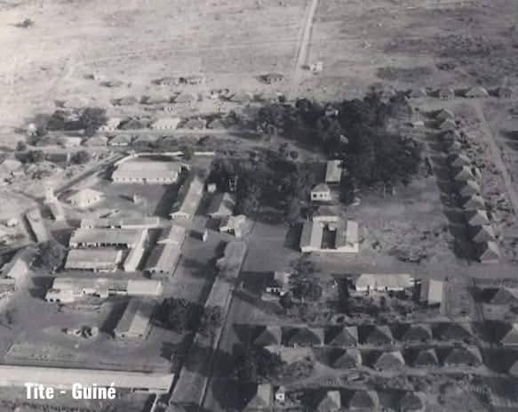
Figure 5. Aerial view of Tite, Portuguese Guinea, c. 1960s–1970s. Photograph © Correia dos Santos. Reproduced in “Bela foto de Tite, do Correia dos Santos,” Bart 1914 (blog), January 30, 2018. https://bart1914.blogspot.com/2018/01/bela-foto-de-tite-do-correia-dos-santos.html

Portugal framed forced relocation as humanitarian development: a way to give the African people better access to education and health care. And there genuinely was a massive effort toward making the aldeamentos places of health, safety, education, and economic advancement. According to historian Rui Ramos, in wartime Guinea-Bissau “the army drilled 140 wells and built 196 schools, 630 dikes, and 8313 housing units.” There were also legitimate and sizable efforts in building clinics, advancing hygiene, and arranging medical consultations for aldeamento inhabitants. In Tite alone, over a hundred people were vaccinated against smallpox in 1974.
It was through these humanitarian efforts that Portugal justified its forced relocation policy on the international stage. Relocating Guinean populations in order to protect and care for them was an idea “strongly put forward by the [United Nations], which Portugal belatedly joined in 1956. The integration compelled the Portuguese government to a set of obligations to the colonized populations, including health, education, and housing.”
Of course, two things can be true at once. While many of the efforts to improve African lives by way of aldeamentos were genuine, there were also less humanitarian motivations. The aldeamentos were primarily a way to concentrate and control people as a military tactic. At first, this may seem counterproductive. How can the Portuguese convince locals to support them by kidnapping them and forcing them to live in their artificial aldeamentos? Aldeamentos that, in Tite’s case, directly faced active machine gun fire and mortar strikes on a regular basis?
To Spínola, taking hearts and minds away from the PAIGC was just as effective as winning hearts and minds for the Portuguese. What Spínola found so effective about the forced relocation was that it not only brought local populations under Portuguese influence, but it also took them away from PAIGC influence.
The PAIGC operated in the countryside. They were especially effective at convincing rural populations to join their cause. Amílcar Cabral took this matter exceptionally seriously. He would have his troops practice talking to villagers and to the village leader before entering a new location. Cabral would observe. If he found mistakes in his soldiers’ communication or logic, he would make them start over. Cabral and his troops would learn as much as they could about a village and its leader before entering–how it operated, its history, its concerns, and its troubles. They would then directly and effectively sway these villages under PAIGC influence. The PAIGC was the picture of efficiency when it came to winning the hearts and minds of rural populations.
Spínola, then, simply took those rural populations away. He stole them away in his fortified aldeamentos and emptied the landscape of potential allies for Cabral and the PAIGC. Spínola saw negative-space as Portuguese-controlled space. It was a chess-like defensive maneuver. And it was effective. It was also significantly cheaper than launching large-scale battles.
Forced relocation was an especially necessary tactic for the Portuguese in the southern region, where Tite was located. An official Portuguese military document from 1965, before the forced relocation program fully began in 1968, described the southern population as having the highest level of subversion in the entire region. It is no wonder that Tite became such a vital area for forced relocation as well as imprisonment.
Tite, while originally a quiet, “uneventful” place, became a significant Portuguese military base upon the initial PAIGC attack in 1963. It then became a sizable aldeamento in 1968 upon Spínola’s transformation of Portugal’s tactics. Tite’s wartime history can essentially be split into two time periods. Between 1963 and 1968, during Schulz’s tenure, Tite was primarily a colonial outpost, consisting of a military garrison and prison as well as a few scattered shops and housing units. It existed to fortify Portuguese forces and to crush PAIGC rebels in the southern regions, while catering to a small Guinean population.
In 1968, upon Spínola’s takeover, Tite transformed. It maintained its garrison, prison, and military power, but also began receiving vast amounts of Guineans from throughout the country. It transformed into an aldeamento alongside a military base, designed to win the hearts and minds of the locals while simultaneously combating PAIGC militants.
Tite was an aldeamento that received locals from all directions. It received locals who were kidnapped and forced there by the Portuguese as well as locals who were fleeing PAIGC violence. It also received ambitious capitalists who saw Tite as an economic opportunity. Tite was in the highly dangerous southern front where, as will be detailed in Chapter Three, it was regularly attacked by PAIGC forces for the duration of the war. It was surrounded by a barbed wire fence and, as Rui Aristides Lebre noted, the resettled natives lived near this perimeter, primarily to the south and west. They were strategically placed there to act as a further shield to the garrison, barracks, and other military installations toward the center.
The grid-like dirt roads were red, oxidized after years of enduring Guinea-Bissau’s relentless rainy seasons. Kapok, cashew, baobab, palm, and mango trees lined the roads and provided shade for the citizens and their numerous domesticated pigs, goats, and chickens. The bottoms of the trunks were sometimes coated white with lime to protect them from pests and sun damage. The locals’ residences were made of adobe, wood, thatch, and reeds. Large concrete barracks and mess halls with corrugated metal roofs lay in ninety-degree angles through Tite’s center. All the buildings were low and flat. Tite’s only tall structures were a metal water tower that peaked over the trees and a scattering of flag poles proudly displaying the Portuguese red and green.

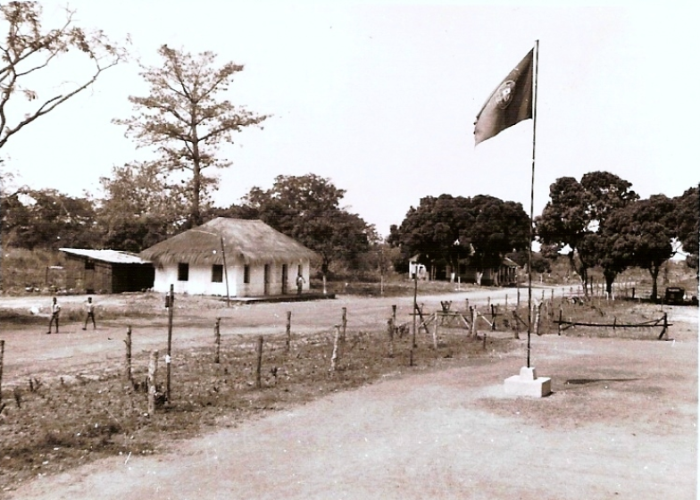
Figure 6. Sergeants’ mess, Tite, Portuguese Guinea, c. 1960s–1970s. Photograph © Santos Oliveira. Reproduced in Blogue Força Aérea, Não Há Guerra Como Esta, February 27, 2008. https://blogueforanadaevaotres.blogspot.com/2008/02/guin-6374-p2504-o-bca1860-o-3-bat-em.html

Tite had its own Catholic chapel and a more recently constructed Muslim Mosque. The confluence of Christianity, Islam, and native religions was and is a unique trait of life in Guinea-Bissau even today. An active airstrip was utilized along the outskirts of town. The rice fields were located away from town in dangerous, exposed land. In the center of town was a large cross and stone stele with the cruciform body of Jesus carved in high relief.
Tite was one of the more sizable aldeamentos in Guinea-Bissau. Its scale and array of amenities (Tite was even host to the occasional film night in the garrison) were not necessarily the standard by which all Portuguese aldeamentos were built. Portuguese soldiers coming from another aldeamento called Nova Sintra described Tite as having much better facilities. There was a diverse range of aldeamentos throughout Portuguese-held Guinea-Bissau, Mozambique, and Angola. According to Rui Aristides Lebre, “many aldeamentos amounted to little more than internment or concentration camps surrounded by barbed wire.”

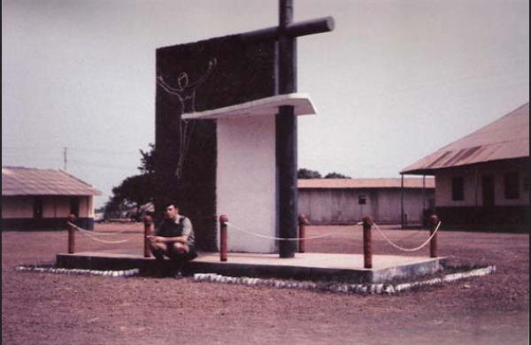
Figure 7. Soldier next to cross stele, Tite, Portuguese Guinea, December 1972. Photograph © José da Câmara. Reproduced in Blogue Força Aérea, Não Há Guerra Como Esta, July 25, 2011. https://blogueforanadaevaotres.blogspot.com/2011/07/guine-6374-p8597-memorias-e-historias.html

Mobility was highly restricted in Tite and similar aldeamentos. Movement in and out was monitored and individuals were only allowed to leave with express permission of the local authority. Many Balantas attempted, to varying degrees of success, to escape aldeamentos and return to what remained of their original villages and rice paddies.
António de Spínola took charge of Guinea-Bissau in 1968. That same year, immediately after the introduction of Portugal’s forced relocation tactics, Tite began to receive native Guineans en masse. Villages and rice paddies in the borderlands around Tite were burned and destroyed throughout 1968 and the surviving residents were forced to Tite. Spínola’s tenure as governor was marked by a bipolar obsession with winning the hearts and minds of local populations while simultaneously burning down and bombing their homes.
These two extremes can seem difficult to reconcile. Spínola wrote time and time again how important it was to the Portuguese cause that local populations were on their side and saw them as reformers, educators, healers, and protectors. In 1969, he wrote the “fight that in this province occurs is essentially psycho­logical in nature aiming, in the last instance, for the conquest of souls, and these we will conquer more through the strength of reason than the strength of arms.” This was the same year large-scale helicopter patrols circled between Tite and Bissau, burning villages and kidnapping inhabitants in their wake.
Spínola also wrote, “if we intend to integrate what does not want to be integrated or constitute societies of different frames than those societies want, we will never cease to be vulnerable” in 1974, when Portugal was at its weakest and most vulnerable. Spínola understood the damage burning villages was doing to the war effort, but he burned them anyway, convinced that emptying the region of potential PAIGC support was an equally valuable goal.
The destruction of villages and kidnapping of villagers did not slow down in 1969. An official Portuguese military document from 1969 explicitly states that 112 locals were “collected” and delivered to Tite in January alone. Their villages were also destroyed.
Around this time, helicopters were introduced to the war for the first time. They were first used around Tite, not only to use against PAIGC fighters but to destroy villages and displace their inhabitants too. A 1969 operation saw helicopters used to sweep a large circle, from Tite to Bissau, burning villages and capturing locals in the process. Villages were burned partly so people could not simply escape and return home, and partly out of revenge for suspected collaboration with the PAIGC.
The burning of villages was not an aberration. It was a normal and expected aspect of Portuguese operations. They would clear any mines or traps around a village, fight any hostile PAIGC soldiers, seize both locals and prisoners (though the distinction between the two was often nonexistent), and search the area for PAIGC weapons, intelligence, and propaganda. After they were finished, the Portuguese soldiers would burn the village on their way out. Bissau, during the war, was overpopulated due to refugees and faced a housing crisis. There was only one place for the villagers to go: the aldeamentos. Tite was central to these operations throughout the war.
While the Portuguese had official aldeamento relocation policies established by the government and passed down to soldiers, they were not alone in forcing locals out of their villages and into aldeamentos. The PAIGC regularly attacked villages and forced locals to flee, often to the Portuguese for protection. This was not an official, state-sponsored program as was the case among Portuguese administration. It was looser, more opportunistic and fluid military activity that nevertheless resulted in large population shifts from traditional villages to Portuguese aldeamentos.
The two largest ethnic groups in Guinea-Bissau during the war were Balantas and Fulas. Painting in broad strokes, the PAIGC tended to recruit from Balanta populations while the Portuguese tended to favor Fula populations. During the war, there was tension between Balantas and Fulas that often turned to violence. Part of this tension was because, according to Cabral, Balantas and Fulas were natural opposites. Balantas were classless, stateless, and animist. The Fulas were hierarchical, governmental, and Muslim. The Portuguese saw more of themselves in the Fulas because of the Fulas’ piety, structure, and respect for authority.
As a result, the Portuguese created additional tension by openly favoring the Fulas. They consistently removed Balanta chiefs and installed handpicked Fula ones. According to historian Gérard Chaliand, the Portuguese “imposed on the [Balantas] alien chiefs recruited from the Islamicized tribes, but the [Balantas] never accepted them.” These Balantas were then subjected not only to exploitation by the colonial administration, but by the Portuguese-imposed Fula chiefs as well. Balantas were often forced to supply labor for Fula landowners and Fulas heavily resisted PAIGC recruitment during the length of the war. The Balantas came to see Fulas as colonial collaborators and aristocratic elites.
There were other fundamental differences between Balantas and Fulas within this ethnic divide as well. The PAIGC, comprised mostly of animist ethnic groups like the Balantas and Manjacos, emphasized the importance of educating girls and relied on women to work and fight during the war. The active role of women in society was not one that was easily embraced by the Muslim ethnic groups, namely the Fulas and Mandinkas. Arranged marriage was an especially volatile issue within the ethnic divide. Muslim Guineans considered girls marriageable at twelve or thirteen and saw marriage as a strategic, economic tool. Animist Guineans, which comprised the bulk of the PAIGC, considered women marriageable at around eighteen and emphasized a woman’s freedom to choose her own partner.
The tension created by this ethnic divide tragically and repeatedly boiled over when PAIGC troops attacked Fula villages. Anthropologist Joanna Davidson includes an account of such ethnic-based violence in her dissertation. A village called Sangatutu was attacked by PAIGC fighters who specifically targeted Fulas. They killed entire Fula families, even the children, forcing survivors to flee.
When such attacks occurred, it was not at all uncommon for these displaced Fulas to seek protection in Portuguese aldeamentos. There are records of local Guineans, mostly of Muslim ethnic groups, voluntarily moving themselves into Tite, seeking protection from the ethnic violence of the PAIGC. The PAIGC also occasionally carried out kidnappings of all types of people for strategic purposes. Such kidnapping victims often escaped, fled, and found their way to Tite. A Portuguese military document from 1970 states “that the [native] populations are discontent with the terrorists, whom they blame for suffering the consequences of the . . . bombings. Many would like to present themselves [to aldeamentos].”
The Portuguese quickly caught onto this and advertised aldeamentos as places locals could be safe and protected from hostile PAIGC forces and practice their religion and culture in peace. Tite, with its Muslim mosque, was one such aldeamento where displaced Muslim Guineans could be protected from PAIGC violence.
The PAIGC, through its attacks on Muslim communities, helped embolden Portuguese aldeamento populations. However, this was not necessarily a drawback for the PAIGC’s war effort. While Spínola was captivated with the idea of creating vast dead zones around Tite and other important aldeamentos, the PAIGC adapted and used these zones to their advantage. Mobility was traditionally one of the biggest strengths of PAIGC forces. They could simply outmaneuver the Portuguese on land and were able to quickly cover large areas in a short amount of time. By destroying villages and removing populations around state-controlled aldeamentos, the Portuguese inevitably allowed for even greater mobility among the PAIGC.
Spínola was aware of this drawback, and determined the tradeoff was worth it. To him, controlling local populations was more important than hampering PAIGC mobility. To the PAIGC, however, utilizing these dead zones and attacking pro-Portuguese Muslim populations was more important than maintaining traditional villages.
As a result, both the Portuguese and the PAIGC were able to use the forced resettlement of native populations into Tite and other state-controlled aldeamentos to their advantage. The Portuguese were able to consolidate populations under their control in Tite and create a buffer zone in the important southern region that the PAIGC could not influence. The PAIGC was able to remove communities that resisted their influence and utilize said dead zones to enhance the mobility of their guerrilla units. Both groups found success utilizing forced relocation in and around Tite, to the misfortune of the relocated individuals themselves.
In this way, Tite serves as a specific example of the role Guinean populations played in the war throughout all of Guinea-Bissau. Both the Portuguese and the PAIGC used populations as strategic items, moving them around a map like pieces on a chess board. While it was important to the Portuguese and the PAIGC to win the favor of populations, it was more important to have them physically placed in the geographic areas that would provide the greatest military advantage.
By the 1970s, Tite was no longer merely a small town attached to a military garrison. It was a forced village, a buffer of human bodies between Portuguese and PAIGC firepower, and a refuge/camp for civilians dragged or driven there by both sides. Chapter Three examines the individuals within Tite itself and asks: once people were in Tite, how was their daily life governed? Who controlled Tite and held power over its inhabitants?
Throughout this thesis, the concept of power and control refers to two modes: Administrative power and control (taxation, policing, detention, food distribution, schooling, housing development), in which Tite was held by the Portuguese; and coercive, situational control (ability to impose danger, interrupt logistics, shape transport, and influence morale), in which Tite was held by the PAIGC. As will be discussed in the following chapter, Tite was unusual because both modes overlapped in the same physical space.

Chapter Three
In 1970, a young Mandinga man named Koné Sané travelled from Guinea-Bissau to Senegal to visit his aunt. There, he was approached by a stranger who introduced himself as a member of the PAIGC. The stranger knew Sané was a student who was interested in furthering his studies. He told Sané that if he joined the PAIGC, he would be able to travel to the Soviet Union and continue his education there, all without having to pay anything. Sané agreed and left his aunt’s house with the PAIGC recruiter.
Shortly after, Sané was taken to the Republic of Guinea-Conakry for military training. He was able to speak with the PAIGC’s leader, Amílcar Cabral. Sané told Cabral he was not interested in military training in Conakry–he wanted to go study in the Soviet Union like he was promised. Cabral was sympathetic, but informed Sané that all the scholarships for that year had already been filled. Sané was told that if he could wait, it was likely he’d be able to get a scholarship to study abroad the following year. He agreed to stay. Sané finished his training and participated in several combat missions against the Portuguese, getting wounded in the leg in the process.
Sané soon grew disillusioned with the PAIGC and no longer thought international study was possible. He obtained a 95-day leave from his unit and traveled to Bissau where he hoped to gain employment. Unsuccessful, he returned to his unit in Senegal before his leave expired. Upon his return, he was immediately seized by the PAIGC and accused of being a spy. Bissau was controlled by the Portuguese and his activity there was viewed with great suspicion. He was locked in a PAIGC prison for 84 days.
Upon his release and having no other options, he went back to work for the PAIGC. He was ordered to travel to Guinea-Bissau on an information-gathering mission, where he was arrested by the Portuguese and accused of being a PAIGC spy–which he was. He was interrogated, then flown to Bissau and imprisoned for an unknown amount of time.
Sané’s experience was not an uncommon one during Guinea-Bissau’s War of Independence. He was not particularly sympathetic to the Portuguese, nor was he particularly passionate about independence. He just wanted an education and a career and a comfortable life. Sané joined the PAIGC because he could not get an education in his home under the colonial regime. He went to Bissau looking for work because he was injured in combat and could no longer fight. He was imprisoned by the PAIGC because he left to look for work. He agreed to spy for the PAIGC to get out of prison. He acted as an informant for the Portuguese but was thrown in a prison in Bissau.
He was in an impossible situation, along with countless contemporaries in wartime Guinea-Bissau. Guinea-Bissau was a parallel state during the war–simultaneously run by the PAIGC and the Portuguese. For many Guineans, like Sané, neither option was a good one. Historian Rui Aristides Lebre interviewed a man in Tite named Camare who recounted a similar predicament.
Camare was forced to work for the Portuguese during the war because if he didn’t, he feared the “Tugas” (Crioulo for Portuguese) would suspect he was working for the PAIGC and punish him accordingly. “At the same time, PAIGC units would ‘come to the tabanca (village) threatening us of betraying the cause … it was a terrible time’, he summarised. This was a conundrum faced by many who, like Camare, wanted to ‘make war neither for the Tugas, nor for the PAIGC.”
Additionally, those within the Balanta ethnic group were uniquely vulnerable to exploitation by both the PAIGC and the Portuguese. They were historically a stateless and chiefless group. This made the Balantas a prime target for recruitment be it through propaganda, bribery, or force.
In the previous chapter, I described how both the Portuguese and the PAIGC physically moved populations away from their traditional villages and into Tite and other state-controlled aldeamentos. Both the Portuguese and the PAIGC then used this population displacement to their advantage in their respective ways. However, the Portuguese and the PAIGC also used the people themselves to their advantage by controlling daily life in Tite and by maintaining relentless propaganda campaigns during the length of the war.
Tite was held by the Portuguese during the entirety of the independence war. Naturally, the aldeamento was under strict rule by the colonial administration. The Portuguese had built the aldeamento and brought most of the population to live within its boundaries. The colonial soldiers and administrators made the rules and the schools, churches, stores, rice paddies, clinics, and houses belonged to them. The population of Tite was allowed to use the facilities, but they owned none of it.
Anyone arriving in Tite, voluntarily or otherwise, was subject to interrogation about rebel activity in the area and access in and out via the roads and ferry was tightly controlled. Inhabitants of Tite were conditionally protected. They had to give up their rights and freedoms, had to be consistently tracked and monitored, and had to contribute to the Portuguese war effort. Administrators in Tite saw its inhabitants through the lens of strategic usefulness. They were only protected if they were useful, and usefulness was never permanent nor guaranteed.
The Balantas, historically, were a stateless and chiefless ethnic group. The Balantas in Tite, however, could not afford to be. They had to submit to the Portuguese administrators. If they didn’t, their conditional protection was taken away and they were severely punished. In Tite, Balanta youth could not perform their coming-of-age rituals, and their ceremonial dancing and music was either banned outright or severely limited.
Colonial control extended not only to movement but also to production. Agricultural production in Tite was not done in the traditional way, but with more modern, colonial methods. Chainsaws were brought into Tite to clear surrounding vegetation for new fields closer to the aldeamento. Tractors were imported and fields were equipped with pumps and pipes connected to Tite’s water tower. Colonial administrators regulated the sale of rice and other goods produced in Tite and required their approval before being placed on the market.
Under Portuguese control, Tite transformed from a small outpost with a single school, a couple small stores, and a garage to a bustling, developing town. This growth attracted an “emerging entrepreneurial class” to Tite who came voluntarily to seek success and profit. A class divide then became present among Tite’s inhabitants under colonial control. Individuals who had their villages burned down or who had escaped PAIGC kidnapping watched ambitious business people voluntarily coming to Tite to open up restaurants, bars, music halls, and escort agencies. This was a stark contrast to the people anthropologist Michel Agier called the “undesirables” who hobbled, injured, sick, hungry, and thirsty; treading remnants of ash, soot, and blood from their demolished lives into Tite.
Of course, a sizable number of people in Tite weren’t Guineans subjected to colonial rule, but the colonial soldiers themselves. Portuguese soldiers, rather than police, provided most of the enforcement in Tite. However, during the war the roles of police and military were blended. Soldiers often performed identity checks, searches, seizures, and arrests. Police often had to perform military roles as well.
Soldiers in Tite had to be ready for constant attacks at any time of day or night. Patrols outside Tite regularly encountered well-hidden landmines and guerrilla ambushes. And yet, the military garrison and barracks inside Tite were often the site of music, games, jokes, and laughter.
During periods of no combat, soldiers in Tite’s garrison spent time playing cards, writing letters, and listening to music. A few soldiers managed to bring elaborate sound systems with them to the garrison. Pranks were constantly present in the garrison as well. Balancing a basin of water on top of a door was an old favorite, as was hiding a hose in the false ceiling over a soldier’s bed and turning it on after lights-out.
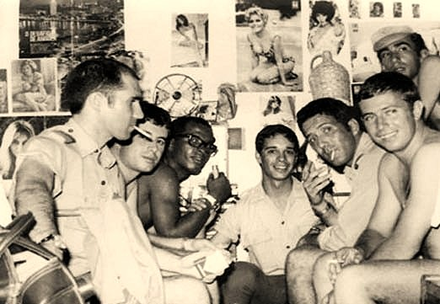
Figure 8. Sergeants’ room, Tite, Portuguese Guinea, 1969–1970. Photograph © Aníbal José da Silva, CCav 2483/BCav 2867. Reproduced in Blogue Luís Graça & Camaradas da Guiné, 2025. https://blogueforanadaevaotres.blogspot.com/2025/06/guine-6174-p26884-scem-comentarios-70-o.html

In the early 1960s, Portugal began heavily recruiting native African soldiers from the Guinea-Bissau region to serve in its colonial military. Though it lessened over the years, white Portuguese soldiers tended to distrust the native African Portuguese soldiers, “seeing in every Black man a potential terrorist.” As the war dragged on and white Portuguese soldiers began to suffer from low morale and started deserting, command in Lisbon relied more and more on the African troops.
Africans brought local knowledge of terrain, languages, and guerrilla tactics, and this skill and knowledge significantly reduced Portuguese casualties. African recruitment also included propaganda courses designed to prevent African soldiers from joining the PAIGC. There were mixed-race units as well as African-only units. In Guinea-Bissau, there were even elite all-African commando units fighting for Portugal. These layered military and social roles deepened the ambiguity of authority within Tite.
There was one last group of individuals who came to live, however briefly, in Tite during the war. These were the former PAIGC members who had defected. Often, when a PAIGC member deserted, they would hide out in the Republic of Guinea-Conakry, Guinea-Bissau’s neighbor to the south. Because Tite lay in the southern region, these deserters often passed through Tite on their way across the border, spending some time in the aldeamento in the process. A common south-bound escape route included travel by boat from Bissau to Bubaque, then to Canhambaque, and eventually through Tite. This activity greatly increased Portuguese suspicion of transitory Guineans and caused any local outside their village (even the burned down ones) to be seen and treated as suspected dissidents.
Life in Tite during the war was marked by what anthropologist Victor Turner described as liminality, or a quality of ambiguity or disorientation that occurs in the middle stage of a transition. This transition can be a ritual or, as in Tite’s case, a place. Tite, along with other aldeamentos in Guinea-Bissau, were transitory, liminal spaces. They existed, not unlike refugee camps, essentially as “waiting rooms,” as Michel Agier puts it.
These waiting room spaces are inherently paradoxical. They are initially justified as temporary emergencies, yet they persist and become long-term. Portuguese Aldeamentos were never designed to be permanent fixtures of Guinean life. They were a military tool used in a broader strategy of winning a temporary war against the PAIGC. Tite was also, to borrow another concept from Agier, extra-territorial: it didn’t belong to the national space around it, and entering it involved a rite of passage like being displaced from a village or defecting from the PAIGC.
Tite became a liminal space as soon as the war started and became even more ambiguous and transitory upon the introduction of Spínola’s aldeamento program in 1968. According to the Portuguese, Tite was a village. A place of permanence where locals could live, work, be educated, raise their families, and be healthy and content. Tite was indeed that, to a few. But to most, that is not what Tite truly was. It was a confusing, contradictory place stuck in a liminal crossroads between crisis and deviation. It existed to create negative space, to remove people from where the Portuguese did not want them. It existed to instill pro-Portuguese sentiment into populations. It existed to act as a human shield for the military garrison. Its population was not seen as human but as chess pieces in a tactical game of insurgency and counterinsurgency.
Tite’s liminality can be observed in specific cases. One Portuguese colonial document describes an anonymous local man who was brought to Tite under suspicion of working with the PAIGC. The document is vague, but suggests the man was either kidnapped or arrested by PAIGC rebels for a time. The man was left without a home or a job after his mother died and was trying to sell rice near Tite. After he was able to leave the PAIGC’s binds, he was taken to Tite and “detained in the Tite barracks, not as punishment, but because there is nowhere else for him to go.”
The phrase, “because there is nowhere else for him to go” is a telling one and betrays the normative situation for a Guinean Tite resident during the war. The Portuguese systematically burned villages around Tite, forcing their inhabitants into the aldeamento as their only option. Those same residents often felt profound fear of the PAIGC as well. A man named Mamadu, interviewed about the war by a German international research center, described how his village “was caught in the crossfire: on the one hand there was a Portuguese barracks barely two kilometers away from us, on the other hand, PAIGC fighters were camped about four kilometers in the other direction.” He ended up in a Portuguese aldeamento similar to Tite after the fighting in his village got so intense he had no other choice.
For Rui Aristides Lebre’s article on Portuguese aldeamento programs, he carried out a series of interviews in Tite. One of which was with an elderly woman named Sofia who described how difficult and dangerous life in the countryside with the PAIGC was. Death was “ever present,” and she had almost nothing to wear and to eat. She describes her relief in moving to Tite, where she was safe and had comfort and peace. Her experience was not unique. Many locals came to Tite and found food, education, medicine, technical training and career opportunities.
Others, like a woman named Benita also interviewed by Rui Aristides Lebre, described the horror of the constant mortar attacks and gunfire descending on Tite from the attacking PAIGC, as well as the screams of torture coming out of the military garrison.
This duality was a consistent trait of life in Tite. For some, Tite was a peaceful haven away from the dangers of the PAIGC and the horrors of the war. A place where they and their family could find refuge, go to school, practice their religion, work, grow food, and be at peace. For others, Tite was a place of constant violence and death. A place they were forced to live as prisoners after their homes were burned to the ground and their crops razed.
Tite was not singularly a village or a military base, a prison or a refuge. It was not entirely controlled by the Portuguese nor the PAIGC. “Liminal,” as Turner used it, is not a decorative word. It is the only usable category for a place that could be, in the same afternoon, a refugee camp, a military base, a labor site, a propaganda theater, and a kill zone.
Tite was simultaneously a place of plenty, opportunity, and safety while also being a place of danger, death, and oppression. These two realities existed alongside each other in an amorphous, ambiguous relationship. “Spaces such as the military club, the various bars in town, the military canteen and hospital, functioned as social aggregators. Although violence whether suffered directly, heard, seen or suggested – was ever present, the experience of possibility and growth equally persisted in many people’s memories.”
Before the war was officially over, the PAIGC held elections and instituted Guinea-Bissau’s new, independent government. For a time, there were two equally powerful governments controlling the country. The old Portuguese regime was still in power, but the new PAIGC government was officially declared as well. Which government was more legitimate depended on who was asked. Guinea-Bissau, in the later years of the war, was a sort of parallel state. It existed simultaneously as two separate and distinct entities. Tite was a microcosm of this duality. Tite was a parallel village. At once a Portuguese aldeamento and a Guinean town.
This state of duality and of being “caught in the crossfire” that marked life in Tite reveals the fact that life in Tite was not only controlled and dictated by the Portuguese. It was equally controlled by the PAIGC who, for the length of the war, had Tite under a permanent state of siege and attack from outside its barbed wire perimeter.
While Tite was controlled by the Portuguese military for the entire duration of the war, the PAIGC had just as much influence over life in the southern aldeamento. Tite was under constant attack, from the very first shots of the war in 1963 to the last in 1974. It was firebombed and attacked with rifles in 1964. Mortars and bazookas were used on Tite in 1965, forcing Portuguese engineers to build mortar shelters there. In 1966, mobile convoys operating out of Tite were ambushed and bombarded so much and so often that when helicopters started landing anywhere near Tite soldiers would shoot blindly into the bush during the descent. 1967 saw Tite attacked three times in less than a month and the Portuguese desperate for anyone to fill vacant administrative posts in the dangerous southern front.
Significant Portuguese casualties occurred due to attacks in Tite in 1968 and 1969. PAIGC landmine use and placement improved dramatically in 1970 and 1971, making transportation and trade in and around Tite markedly more difficult. Tite was still under constant mortar, grenade, and firearm attacks in 1972 and PAIGC soldiers were able to get leaflets into Portuguese soldiers' hands that emphasized the futility of their cause and encouraged them to defect. The PAIGC downed 73 airplanes and helicopters in 1972 and 1973 with brand new surface-to-air missiles developed by the Soviet Union previously unknown to the West.
The damage to Portugal’s air fleet resulted in increased isolation among garrisons and aldeamentos like Tite. The supply situation was so bad “some Portuguese units were compelled to use captured weapons to combat the PAIGC—an ironic twist in an insurgency, wherein the guerrillas typically comprise the side forced to resort to such scavenging.” When the war ended in 1974, the situation on the ground was still so dangerous that troops in Tite had to be airlifted out.
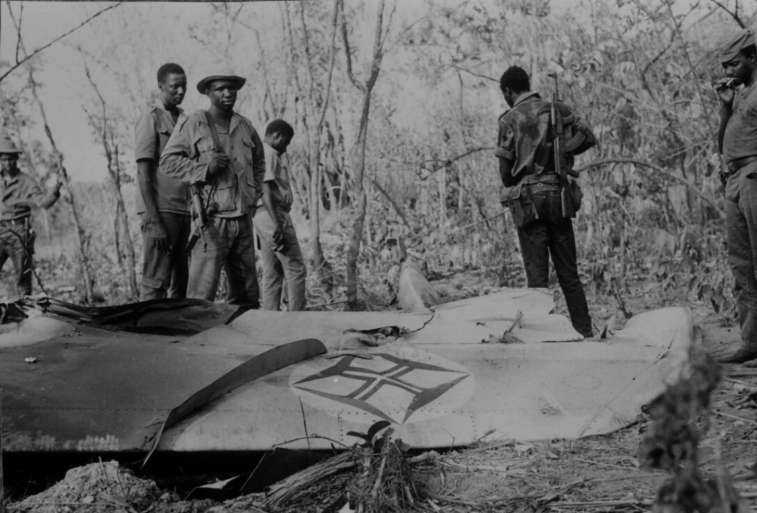
Figure 9. Wreckage of a Portuguese aircraft, Guinea-Bissau, 1974. Photograph by Roel Coutinho. Courtesy of the Coutinho Collection. © Public domain (via Wikimedia Commons).

The fact that the PAIGC never once stopped attempting to seize Tite shows how important it was to their cause. It is clear through the recorded military activity around Tite during the war that the PAIGC had significant influence over the aldeamento, despite not technically controlling it. But the Portuguese stubbornly continued development. Despite the constant damaging attacks, Tite still had hundreds of students in school in 1965. Tite had language programs and was arming and training local militias in 1967. Between 1973 and 1974, the toughest years of the war for the Portuguese, construction in Tite included: 40 houses built, 53 traditional houses reconverted to zinc roofing, 14 fountains constructed, airstrip maintenance and cleaning, upgrades to roads, buildings, advanced posts, and parade grounds, rebuilding destroyed bridges and clearing trees with chainsaws.
Reinforcements were also summoned to Tite frequently over the years: in 1965, 1966, 1967, 1971, and 1972, at the very least. This insistence on maintaining Tite despite massive problems among Portugal’s military, logistics, and supply network shows how vital Tite was to the waning empire.
In addition to the parallel control over Tite the Portuguese and the PAIGC had, there was also a parallel control over the minds of Tite inhabitants. Portugal and the PAIGC both launched ferocious propaganda campaigns that lasted the length of the war. Both sides of this propaganda battle were present inside the barbed-wire perimeter of Tite.
Portuguese colonial forces screened pro-Portuguese propaganda films for Tite's population in the military garrison and distributed colonial newspapers to Portuguese troops. They also broadcast pro-Portuguese messages over local radio channels in a variety of native languages (Fula, Mandinga, Balanta, and Crioulo). Posters, leaflets, military ceremonies, bulletins, and even awards ceremonies were used in Tite and other aldeamentos.
The Portuguese cleverly catered their propaganda messages to specific ethnic groups. Examples of these catered propaganda messages include: "Allah wants the victory of the Fula and their religion." "Mandingas reunited will again be masters of their ‘chão’ (homeland)." "The army respects the customs of the Balanta. In the forest they are slaves to the enemy; in the villages (aldeamentos), they are free." And "Manjaco together will have weapons and strength to destroy the enemy." The Portuguese insisted on ethnic solidarity as a cornerstone of their propaganda campaign. They asserted that black and white people are all Portuguese and denied the existence of racial discrimination.
The Portuguese not only preached ethnic solidarity in their propaganda, but religious solidarity as well. They ambitiously tried to align Islam and Christianity under one Portuguese banner, and instituted some form of this in practice by constructing a Muslim mosque near a Christian chapel in Tite.
Even though Tite never fell to the PAIGC during the war, PAIGC propaganda was still able to penetrate its outer defenses and into its community. In 1967, the PAIGC officially launched Rádio Libertação, or Liberation Radio, in the Republic of Guinea-Conakry after a few years of experimentation. It was initially run from a Soviet-supplied truck and mobile transmitter before growing in scope and size. Its purpose was to break the monopoly of Portuguese colonial radio in Guinea-Bissau, update militants, motivate populations, and counter colonial propaganda. It broadcast messages not only to its fellow PAIGC soldiers, but to Portuguese soldiers as well as civilian populations throughout Guinea-Bissau.
To the Portuguese soldiers, it urged desertion and emphasized the futility of fighting a losing war for an outdated cause. To the broader populations, it preached anti-Portuguese propaganda but also included traditional Guinean music, interviews, and native language-learning courses meant to bolster African pride and unity. Walls and barbed wire were not enough to stop the broadcasts from spreading into Portuguese-dominated zones.
Historian Alexandra Reza maintains that “clandestine listening practices evolved around Rádio Libertação. One Portuguese soldier said he and his colleagues deployed in Guinea listened to Libertação’s programmes ‘on the sly’ (às escondidas), unbeknownst to the ofﬁcers at the base.” Similar clandestine listening activities doubtless would have occurred among the citizens of aldeamentos like Tite. In fact, one fable told by the PAIGC’s Liberation Radio centered on Tite and spoke to its inhabitants. Its abridged version goes like this:
There was an old man named N’Bunde who lived in Tite with his wife and two sons. Every day old N’Bunde worked the fields with his family but he remained poor and perpetually exploited by the Portuguese. One day his neighbor told him about a great Party in which all lived as brothers–Balantas, Cape Verdeans, Fulas, Manjacos, and Papel.
Old N’Bunde was excited by the prospect and joined the Party. The Party and its guerrilla fighters, with N’Bunde’s help, were able to expel the colonizers. Afterwards, a teacher arrived and said: “The Party ordered that all the people must learn to read–men, women, and children.” N’Bunde laughed and said he was too old to learn to read, that only his children should learn. But the teacher insisted that everyone was equal and must learn equally. So the old man, along with his wife and children, learned to read. Then they built a beautiful new house and increased their crop yield. N’Bunde, with the help of the Party, lived long enough to be able to say: “Now everything goes well for us. Long live the School! Long live the Party! Long live the People of Guinea and Cape Verde!”
Besides taking place specifically in Tite, the story is fascinating in that it focused on literacy as a reward for expelling the colonists. PAIGC radio broadcasts were especially effective because of the high illiteracy rates (up to 99% of the population) throughout Guinea-Bissau under Portuguese rule. The PAIGC produced a vast array of newspapers, posters, and leaflets but because of the staggeringly high illiteracy rate radio broadcasts were their most effective method of communication.
The Portuguese also had a radio station used for disseminating propaganda. Though Portuguese radio was older, beginning in earnest in the 1950s, it is safe to say the PAIGC’s Liberation Radio was significantly more effective, both as a medium for propaganda and as a military tool, than the Portuguese broadcasts.
Portugal’s early radio broadcasts were aimed exclusively at the white population, despite Portugal’s Lusotropicalist ideals of racial integration. Eventually, Portugal started broadcasting to Guinea-Bissau’s diverse population, including broadcasts in Fula, Mandinga, Balanta, and Crioulo. Even then, the PAIGC’s Liberation Radio broadcast in more languages (Portuguese, Crioulo, Balanta, Biafada, Mankanya, Manejo, Fula, and Mandinga) and contained a much more diverse array of programming than Portuguese broadcasts.
Both the Portuguese and the PAIGC, through various mediums, encouraged each other to defect and desert their units. The Portuguese told the PAIGC that soldiers who switched sides would be well treated, compensated, and promoted. The PAIGC told the Portuguese they were on the wrong side of history and fighting a battle that, given enough time, would inevitably be lost.
While it is difficult to show how effective these respective propaganda campaigns were in Tite specifically, the PAIGC were able to consistently recruit throughout the war and the Portuguese were able to frame the PAIGC as terrorists bent on disrupting the lives of everyday citizens.
Additionally, both the Portuguese and the PAIGC propaganda campaigns in Tite and elsewhere that were designed to encourage the enemy to defect were effective. PAIGC soldiers were known to defect and present themselves to Portuguese authorities. Similarly, Portuguese soldiers were known to abandon the colonial war and abandon the military.
Though Tite and its inhabitants were, on the surface, controlled by the Portuguese colonial administration during the war years, over a decade of attacks from the outside resulted in a dual governance over Tite by both factions. The minds of Tite’s inhabitants, too, were influenced by both the Portuguese and the PAIGC due to over a decade of propaganda campaigns.
Control of Tite was never total. Even inside the perimeter, PAIGC mortars, landmines, and radio broadcasts made the aldeamento feel provisional, temporary, and besieged. Long before the aldeamento system reached full scale, Tite functioned as a detention and interrogation site. Under Spínola, that earlier prison complex was folded into the new population-control strategy, giving it renewed importance. The following chapter examines this carceral Tite and its role in Portugal’s broader counterinsurgency network.

Chapter Four
In January 1970, according to a Portuguese patrol report, colonial soldiers captured an anonymous, undocumented Guinean man. He was apprehended along a stretch of road running north from Tite up toward the Geba Estuary. It was in the middle of Guinea-Bissau’s dry season, around six o’clock in the evening. The Harmattan wind: a hot, dry, dusty wind that comes in from the Sahara, had died down for the evening. Outside this scene, the rest of the red dirt road was quiet and still.
The soldiers forcefully loaded the man into the back of a military truck, which began to move south down the dry, dusty road toward Tite. The Portuguese soldiers were taking the mysterious, suspicious local man to the aldeamento for interrogation. These interrogations regularly took place in Tite’s military garrison. Word had gotten around about Tite’s cruel and torturous conditions many suspected rebel sympathizers faced and the man in the truck was understandably terrified.
Before the vehicle arrived, the apprehended man leapt from the bed of the truck, disappearing into the cloud of red dust kicked up behind it. To him, taking his chances fleeing from his armed captors was a better course of action than being held in Tite’s cruel penal system. He ran as fast as he could down the road and into the bush, but the Portuguese soldiers gave chase–not the safest course of action given the abundance of landmines in the region. It was not long before he was overtaken, knocked down, bound, and placed back in the truck. The vehicle rattled on again, eventually arriving in Tite. The red dirt road settled into the night, hosting the occasional foraging mongoose and civet.
Two years later, in 1972, the 849th “Meeting of the Special Committee on the Situation with Regard to the Implementation of the Declaration on the Granting of Independence to Colonial Countries and Peoples” was held by the United Nations in Conakry. The focal point of this meeting was the situation of war, colonialism, and independence in Guinea-Bissau and the Cape Verde islands. Amílcar Cabral, along with several other PAIGC members, were present.
Cabral and his cohorts had come before the United Nations to address, among other concerns, the cruel, violent, torturous, and murderous state of Portuguese colonial prisons and detention centers throughout Guinea-Bissau. These prisons held many innocent people in unacceptably cruel and inhumane conditions. Cabral and the PAIGC believed such conditions had to be recognized and condemned by an international jury.
The first to speak, a man named Korea Djallo, was introduced by Cabral as a former member of the Portuguese colonial police who had defected to join the PAIGC after secretly aiding them for years. At the start of the war, he was arrested without a trial and spent the next five years getting transferred around various prisons including Bissau, Mansoa, Tarrafal, and Ilha das Galinhas.
In Bissau, after an initial fourteen-hour interrogation, he was placed in a lightless, underground cell with seventeen other prisoners. Guards forced Bissau prisoners to kneel on broken glass and then brutally beat and kicked them. Should they pass out from pain or shock, they were revived with cold water so the torture could commence. Questions such as “Where are the weapons?” and “Who else is connected with the Party?” were battered on the prisoners so often many resorted to inventing names and describing imaginary arms caches just to gain a brief respite from the beatings.
Bissau’s prison was extremely overcrowded. Cells designed for one prisoner held up to fifteen. Cells designed for twelve held up to eighty-four. Prisoners were locked in bathrooms. Food arrived in buckets every two days and many, including women (some pregnant or with children) were too weak to reach it. Prisoners were often naked due to the heat. Windows were bricked up, doors reinforced. Suicide was common. Many prisoners were simply murdered by soldiers to combat overcrowding. Guards left dead bodies inside the crowded cells for hours, even days at a time.
Djallo, along with several others, were then transferred to Mansoa’s prison due to the massive overcrowding in Bissau. In Mansoa, administrators feared a PAIGC attack was imminent due to the upcoming anniversary of the 1959 Pidjiguiti dock massacre. Prisoners were placed strategically to act as human shields in the event of an attack. The attack never came. Instead, prisoners had to endure “indescribably filthy” conditions and twice-daily beatings by a cruel Portuguese captain nicknamed “Speak the Truth.” Speak the Truth bound and clubbed prisoners, at least one dying every day. The bodies were left outside each night as warnings to the other prisoners.
Djallo and thirteen others were then relocated to Ilha das Galinhas. He reported witnessing soldiers forcing prisoners to run, who were then machine-gunned down. The soldiers then claimed the prisoners had tried to escape. Physical agricultural labor was forced and mandatory at Galinhas and prisoners were commonly shot for the slightest perceived act of defiance–even something as innocuous as stopping to stretch during work. Food at Galinhas was rice intentionally mixed with stones. Prisoners here were not allowed to bury their dead. When they tried, they were told that the “vultures had a right to eat.”
Around one hundred prisoners, including Djallo, were shipped from Ilha das Galinhas to Tarrafal, more of a concentration camp than a prison. Prisoners were held outside under the hot sun, many fainting due to the heat. They were tightly packed, kept under constant armed watch, and forbidden to talk or laugh. They received little water, less food, and no medical care. What food they did receive was cabbage and moldy rice. Prisoners were allowed to wash every tenth day. Disease was rampant, and any rule-breaking landed the prisoner in solitary confinement for a week.
During Djallo’s various prison stays, he heard from his fellow prisoners about conditions in other prisons throughout Guinea-Bissau and Cape Verde. In Bula, for example, prisoners were held in a sort of natural underground cave and were regularly stabbed to death. Prisoners had their fingernails pulled out in Bissora and were whipped to death in Santo Domingo. In Bafatá, overcrowding led to groups of up to twenty prisoners at a time being forced to dig their own graves near the airport and then shot.
These were not all PAIGC dissidents, or even suspected dissidents. António de Oliveira Salazar’s Estado Novo regime in Portugal was infamous for the imprisonment of innocent people who merely criticized the government. Guinea-Bissau under Salazar was no different. Guineans lamented that thousands of people, including students and youth, had been imprisoned or sent to “famous and infernal” prisons by Portuguese police for simply asking for “a little more freedom” or dignity.
One prison that Djallo did not personally get transferred to but heard about in detail from his fellows was the prison at Tite. Tite, like Tarrafal, was described initially as more of a concentration camp than a prison. Like Tarrafal, it was a large, partially outdoor space, exposed to heavy sun, rain, and mosquitoes. Prisoners were not as tightly packed as they were in Tarrafal. On arrival in Tite, prisoners had their clothing slashed or removed. Their hands were tied with abrasive metal wire. Prisoners were kept distanced from each other and had to stay seated or lying down. Anyone who stood or kneeled would be shot.
The prisoners in Tite were fed the soldiers’ leftovers, often cruelly mixed with cigarette butts and other inedible detritus. Their hands were kept tied with the painful metal wire, and food slop mixed with trash was forced down their throats once a day. One glass of water per day was allowed. Many prisoners in Tite were tortured by being buried up to their necks in holes and by beatings with heavy sacks of sand. Like in Bissau, corpses were common and not removed for hours or days at a time. As the war went on, a more traditional indoor prison was constructed in Tite.
At the meeting, Djallo named Corporal Carreira Curto (also known as Captain José Curto, hereafter referred to as Captain Curto) as the most notorious and cruel of all the soldiers and administrators in the aldeamento. Captain Curto came to Tite in 1961, before the war officially began, alongside one of Portugal’s early military reinforcement units. His nickname was “Chapa ou Fogo,” literally “Plate or Fire.” The chapa, or plate, referred to the badge or emblem of PAIGC soldiers. Curto would demand PAIGC members hand over their emblem or be killed with a fired bullet.
One episode of cruelty and violence is infamously associated with Tite and Captain Curto. It took place in 1962, just before the official start of the war. PAIGC militant activity was ramping up in 1962 as they prepared for open war, and Tite’s concentration camp had already been established for suspected dissidents. Captain Curto and his unit were alerted to the presence of suspected PAIGC militants in a village near Tite. The men raided the village, destroying much of it in the process and killing many. Vitorino Costa, a student and PAIGC member in his early twenties, was one of the villagers killed after trying to defend himself with only a small pistol. It was only 1962, and the PAIGC were not yet properly armed to defend themselves against Portuguese military units.
After the village was thoroughly raided, Captain Curto had his men remove Costa’s heart and head and impale them on a sharp wooden stake. This was then paraded through the remains of the village, as a sort of grisly colonial standard. A warning to those who would consider opposing the Portuguese in the future. Captain Curto thought the warning was effective enough that he took Costa’s decapitated head with him on a tour of villages throughout the southern region of Guinea-Bissau. He took it to Fulacunda, where Costa’s mother lived. He also took it back to Tite where it stayed as a warning to the citizens and as a boast to the PAIGC members imprisoned in the concentration camp. Though Captain Curto was killed early in the war, his harsh legacy of cruelty and punishment lived on in Tite until Guinea-Bissau’s independence.
Between 1963 and 1974, Portuguese authorities regularly interrogated and detained prisoners in Tite's outdoor camp and indoor prison. It should also be noted that colonial prisoners were held in Tite earlier than 1963, though the exact beginning is unknown. In 2001, a Portuguese newspaper interviewed Arafam Mané, the leader of the PAIGC combatants in the initial attack on Tite in 1963. He confirmed that “before the attack on this barracks, an important number of militants of our great party, the PAIGC, were imprisoned there.” He also explained how the original combatants wanted to try and blow open the prison doors with a mine, though this didn’t come to fruition.
While archival documents directly referencing Tite’s concentration camp and prison are rare, there are numerous indirect references to be found. In 1964, a guerrilla fighter was captured in a rural PAIGC camp and taken to the Tite barracks for interrogation, where he was compelled to reveal intelligence on guerrilla activity in Gandembel, Tehanbi, and Tcharbú. In 1965, a Balanta missionary teacher named Cristiano Vieira was arrested and sent to Tite. Fortunately for Vieira, he was one of the lucky few deemed innocent enough to be allowed to leave. He ended up leaving Guinea-Bissau entirely, seeking asylum in Hungary.
Luis Cabral, brother of PAIGC leader Amílcar Cabral and first president of independent Guinea-Bissau, went on record in 1967 claiming that a recent attack on Tite had been successful. He boasted that much of Tite’s military infrastructure was damaged and that the PAIGC successfully took great pains to avoid harming Tite’s prison and civilian living quarters. A 1968 administrative document briefly lists the names of four “detainees” taken to Tite in April of that year. Another colonial document briefly mentions detainees being brought to Tite’s barracks in 1969.
By 1970, as described in the opening to this chapter, Tite’s prison was notorious enough that individuals would risk being shot by the Portuguese attempting to avoid being taken there. 1971 saw a dozen Biafada people seized and taken to Tite for interrogation after their village was burned and destroyed by the Portuguese. They initially fled into the forest but were tracked down and arrested. Six members of the PAIGC, including one high-ranking member, were arrested around Jabadá in 1972 and brought back to Tite for interrogation and detainment.
Most official Portuguese documents avoid explicitly using words like “prison” and “prisoner,” opting instead for “garrison/barracks” and “detainee.” Almost none openly discuss torture and other interrogation methods. It is likely that some level of secrecy and confidentiality is associated with prison and interrogation activity in colonial Guinea-Bissau. A rare example of Portuguese torture methods is detailed in an Amnesty International report from 1975:
“The deprivation of sleep was the background of all other torture: physical, psychological, electrical and chemical torture were additional. The torturers would record crying voices, including those of close relatives and play them back to the victim after days of sleeplessness. They would also subject victims, after days without sleep, to readings of jibberish [sic] by agents outside the cell. These methods were intended to increase the victims' feelings of anxiety, to cause hallucinations and to make them believe they were going insane. Manuscripts of jibberish [sic] have been recovered from the PIDE's [Portuguese Police’s] paraphernalia.”
While this report is concerned with torture and imprisonment within Portugal itself, it is likely that official Portuguese torture methods were also utilized within Portugal’s African colonies where torture was an essential military tool. Portugal’s torture methods were developed independently and internally and were kept secret from the rest of the world. They were certainly kept more secret than Portugal’s military activity, which is abundant in the colonial documents. As a result, colonial documents must be interpreted with a degree of speculation regarding Tite’s prison and concentration camp and the conditions therein.
An example can be found in a large trove of documents not from Tite, but from Ilha das Galinhas. Ilha das Galinhas, or Chicken Island, is an island in the Bijagós Archipelago of Guinea-Bissau. Before and during the war, it housed an agricultural prison camp in which suspected PAIGC rebels and other dissidents were imprisoned and forced to work. The director of Ilha das Galinhas, James Pinto Bull, was fastidious in his record-keeping and kept documents on every prisoner that was brought to the island. These documents often included where the prisoner was first apprehended or what prison they were in before being transferred to Ilha das Galinhas.
Most prisoners transferred to Ilha das Galinhas, predictably, originated from Bissau. Bissau was by far the biggest population center during the war and its prison was constantly overflowing. However, prisoners were sent to Ilha das Galinhas from all over Guinea-Bissau as well. They came from Catió at the very southern end of the country, even further south than Tite. They also came from Olossato up north, near the border with Senegal. Prisoners came to Ilha das Galinhas from Gabú and Bafatá in the east, as well as Cacheu to the west.
There are two striking things in Ilha das Galinhas’s archived prisoner records. The first is the breadth and scope that the agricultural penal colony had during the war. It housed prisoners from all over the country. It was also not limited to political prisoners. It housed individuals convicted of everything from petty theft to murder. The other striking thing about the prison’s records is that, despite transferring individuals from every corner of Guinea-Bissau, not one prisoner record mentions Tite.
Over four hundred prisoner records from Ilha das Galinhas were digitized prior to this thesis, and not one mentions Tite by name. To be clear, not every prisoner record explicitly states where the prisoner was tried, arrested, or transferred from. It is possible a significant number of prisoners came from in and around Tite and just didn’t have that fact documented in their records. However, a much more likely explanation is that prisoners weren’t transferred to Ilha das Galinhas from Tite because Tite had its own prison during the years Galinhas operated.
Ilha das Galinhas began operation in 1961. Tite clearly had some form of operational prison camp by 1963, likely by 1961. Ilha das Galinhas ceased operation after the war ended in 1974, just like Tite’s prison. It does require a degree of speculation, but the lack of documents mentioning Tite from Galinhas strongly suggests Tite was able to try, process, and imprison all the prisoners in its region. This was no small number of prisoners, as Tite sat in one of the most active PAIGC zones in the entire country. The lack of Tite found in Ilha das Galinhas’s documents also suggests that, despite the high number of rebels and dissidents in the area, Tite’s prison did not have a problem with overpopulation like Bissau’s prison did.
Bissau’s prison administrators dealt with its overpopulation problem in two ways. They transferred their prisoners to Galinhas (as well as São Nicolau in Angola) and they killed them. Korea Djallo, in his testimony before the United Nations, describes how individuals he had known, “such as Professor Vormao de Sousa, Duarte IJ'Bana, Victor Pinhel and many others, had simply been put to death in the PIDE (Portuguese Police) camp at Bissau.”
While archival evidence is yet to be produced confirming this, there is some oral evidence suggesting similar killing took place in Tite. According to historian Mustafah Dhada, who facilitated oral interviews among select Tite inhabitants in 2023, colonial soldiers disposed of prisoners “in what came to be known euphemistically as the ‘practice range’ hidden behind a cashew grove outside Tite opposite the logistical supply air strip.” Future forensic investigators will find the bodies still buried there, near the decaying airstrip, awaiting respectful exhumation. It is unknown whether the killing at Tite took place as a solution to overcrowding or, as the moniker “practice range” suggests, sport.
Additionally, prisoners in Tite were almost certainly subjected to harsh conditions in lightless underground cells. Dungeon-like underground imprisonment was common in Bissau, and photographic evidence suggests similar conditions were present in Tite. Entrances to underground cells remain in Tite, though anthropological investigations into the chambers have not yet been conducted.
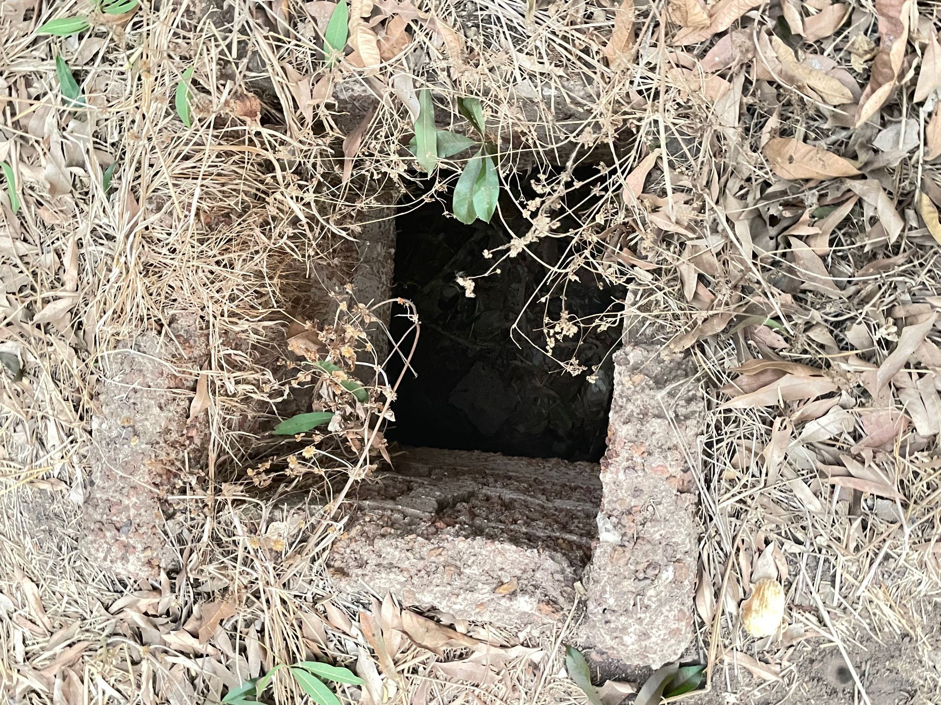
Figure 10. Entrance to an underground cell in Tite, Guinea-Bissau, 2023. Photograph by Mustafah Dhada. © Mustafah Dhada. Used with permission.

Despite the litany of human rights abuses present in Tite and other colonial penal institutions in Guinea-Bissau, their effectiveness in securing military intelligence for Portugal’s war effort cannot be denied. Portugal’s counterinsurgency techniques utilized in Tite and elsewhere were instrumental in the war lasting as long as it did. Portuguese authorities were regularly able to procure valuable information from its prisoners. A 1965 document details information extracted from Gastão Seguy Junior, a former PAIGC member from the south of Guinea-Bissau.
He told the Portuguese of the Russian jeeps, ambulances, and boats Amílcar Cabral had stockpiled in Conakry. He also described how guerrilla fighters had come to Conakry from China with shipments of machine guns, brandless carbines, grenades, and anti-tank bombs that they smuggled over the border into Guinea-Bissau.
A similar document details the interrogation and confession of a former PAIGC driver named José Francisco Gomes, who gave information on a weapons stockpile in a PAIGC base which had come via Algeria. He described how wounded PAIGC soldiers were treated in Senegal, and even named several spies in Bissau.
Again, while official Portuguese documents tend to avoid words like “torture,” it is clear through the terminology that is present and the known brutal nature of Portuguese counterinsurgency that these were not voluntary confessions. The documents use words and phrases like “taken to the barracks,” “detained by the administrator,” and “escorted by the guard.” Through available interviews and testimony, however, it is clear what this soft wording is really referring to.
Portugal was among the last of the European colonial powers in Africa. It held onto its colonies long after other European nations began to recognize the diplomatic, financial, and militaristic folly of holding onto imperial territory in the modern age. Portugal during the late 1960s and early 1970s was, as political philosopher Hannah Arendt put it, “masters in a rather useless and obsolete trade.” The Guinea-Bissau War of Independence was a losing war for Portugal from the start. The tides of history were always against them. Writing the year before Spínola came to power, Gérard Chaliand postulated that the war could not last much longer, that Portugal’s defeat was imminent.
However, Spínola’s unique brand of garrison-based, propaganda-heavy counterinsurgent warfare saw enough success that the war was dragged out much longer than it should have been. A significant part of Spínola’s success was found in the concentration camp, prison, killing fields, and torture chambers of Tite.
The aim of this thesis is not to paint the Portuguese colonial administration in a negative light while praising the acts of the PAIGC. Both sides committed atrocities. However, it is worth mentioning that the PAIGC tended to treat their prisoners significantly better than the Portuguese treated theirs. The PAIGC had its own prisons, but they were not home to the same cruelties, tortures, and inhumane conditions the Portuguese colonial prisons were.
Cabral and the PAIGC regularly emphasized that they were fighting colonialism, not the Portuguese people. Cabral stated that the PAIGC would happily negotiate a peaceful ending to the war upon Portugal’s recognition of Guinea-Bissau as an independent state. The PAIGC not only denounced Portuguese cruelty in their Bissau, Ilha das Galinhas, and Tite prisons, but intentionally treated their Portuguese prisoners well. PAIGC rules stated that prisoners had to be treated as prisoners of war under international law.
A Portuguese military document from 1968 states that three soldiers were taken prisoner by the PAIGC but were treated in accordance with party principles and later released via the Senegalese Red Cross. Though the PAIGC’s treatment of Portuguese prisoners was typically humane, it is likely this was done ostentatiously for purposes of international reputation. The PAIGC’s treatment of fellow Guinean prisoners who betrayed the PAIGC or aided the Portuguese was not as lenient.
While the PAIGC was never successful in breaching and taking Tite, they were still able to use the human rights abuses present within the aldeamento to their advantage. The way they did this was simple and effective: they told the world about it. As detailed in the beginning of this chapter, by 1972 PAIGC representatives were not just describing the war in general terms to the UN but naming individual camps such as Tite as sites of torture in order to argue that Portugal had forfeited moral authority to govern. That naming of specific places like Tite is what allowed PAIGC to present itself not just as an armed movement but as a sovereign actor capable of documenting state crimes and guaranteeing prisoners’ humane treatment.”
By showcasing Portuguese atrocities and highlighting PAIGC civility, the PAIGC persuaded both the Organization of African Unity and the United Nations to recognize them as the genuine diplomatic representatives of Guinea-Bissau. Cabral and the PAIGC were able to use Portugal’s negative reputation to garner a positive international reputation for themselves, specifically among socialist and Nordic countries. Sweden, for example, was a consistent friend to the PAIGC during the war, providing aid and hosting Cabral and other speakers on numerous occasions. Portugal officially acknowledged Guinea-Bissau’s independence in September of 1974, due in equal effect to international pressure, military defeats, and its own internal revolution.

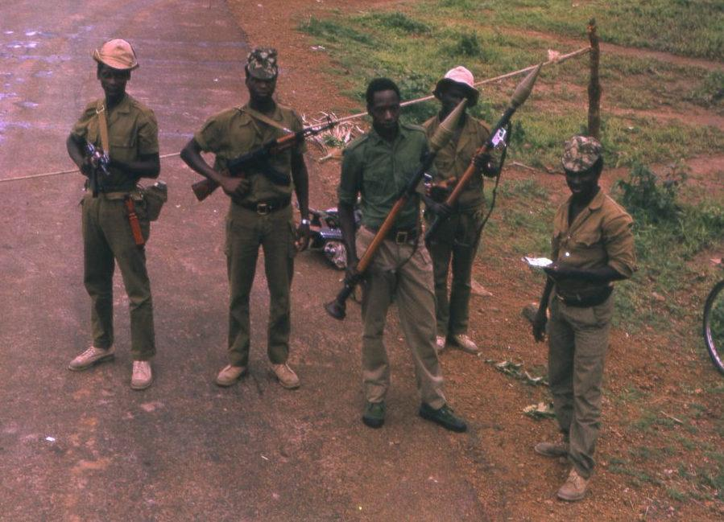
Figure 11. PAIGC checkpoint in Guinea-Bissau after the declaration of independence, 1974. Photograph by João Carvalho. Courtesy of Wikimedia Commons. © Public domain (via Wikimedia Commons).

Yet victory did not erase violence within the newly independent state. Unfortunately, despite the PAIGC’s successful attempts at garnering international favor, one of the first things they did after independence was to summarily execute hundreds of their own political prisoners. Not European Portuguese, which would have resulted in international outrage, but the black African soldiers who had fought for Portugal and were forced to stay behind after the war ended. The number of such paroxysmal executions is claimed to have been as high as 7,000.
This reinforces a broader argument of this thesis: that Guinean bodies in and around Tite were always treated as strategic assets first and as human beings second. The logic and justification of maintaining strategic control over populations through extreme violence did not disappear with independence, at least not right away. It was inherited.
While information on these executions immediately post-war is scarce, it is likely that Tite was home to many of them, according to preliminary research. Future oral methodology, archaeology, and forensic investigation is required to confirm this.
The story of wartime Tite reveals more than the brutality of one outpost. It exposes the anatomy of colonial collapse. Within its barbed-wire perimeter, the decay of one of the last overseas European empires played out in miniature. Tite’s violent counterinsurgency program was not an isolated policy but an interconnected instrument of a failing colonial system fighting to stay alive by any means necessary. The same mechanisms that sought to sustain Portuguese rule ultimately accelerated its demise, as the violence and dehumanization exercised in Tite helped to erode any remaining moral legitimacy Portugal once had. What unfolded in Tite between 1963 and 1974 was both the culmination of centuries of imperial rule and a harbinger of its end.

Conclusion
In tracing the wartime transformation and dual functionality of the aldeamento of Tite, this thesis has shown that Guinea-Bissau’s struggle for independence was not only a multinational rebellion against an old-world empire, but also a series of small-scale local movements in which individual minds and spirits were fought over like fortified bases. The war’s origins, its tactics of control and propaganda, and its legacies of violence all converged within this one small aldeamento roughly half a kilometer in size. Focusing on Tite rather than the entire country allows us to see how the broader systems of colonial power and anti-colonial resistance manifested in daily life, in the forced movement of people, the reshaping of landscapes, and the contest over minds and bodies.
Portugal entered the war with a fragile identity. It was torn between old colonial ambition and modern desperation in an increasingly anti-colonial age. Through the Estado Novo’s ideology of Lusotropicalism, the regime claimed to represent a humane, plural empire, uniquely suited to tropical coexistence. Yet in Guinea-Bissau, Lusotropicalism became a fiction sustained only through violence and coercion. The aldeamentos, framed as instruments of modernization and safety, served instead to concentrate, surveil, and exploit. In Tite, this paradox reached its most visible form: the colonial promise of modern civilization realized through the archaic mechanisms of torture, indiscriminate imprisonment, and fear.
The PAIGC, by contrast, sought to embody the opposite principle: the liberation of land and people through revolutionary struggle. Yet their own actions, including ethnic violence, raids, and kidnapping, often displaced the very communities they claimed to represent and defend. Both forces transformed Tite into a weapon of war. In Tite, Portugal fought to centralize control while the PAIGC fought to disperse it. Civilians were caught between these two sovereignties, living under constant surveillance from within and constant threat from without. Tite became the embodiment of this dual sovereignty. It was an aldeamento under Portuguese law and military protection, yet psychologically and spatially surrounded by rebel powers.
The social world of Tite reveals how war blurred every boundary and norm. Tite was both a refuge and a cage. Its clinic healed the sick, weak, and wounded while its garrison tortured and killed them. Tite’s schoolhouse taught Portuguese grammar as anti-Portuguese propaganda reverberated through its radios. The fortifications around Tite promised security but were bombarded with mortars, grenades, and bullets on a regular basis. In this environment, the Portuguese soldier and the Guinean civilian shared proximity without equality. Both were trapped inside a landscape of colonial oppression.
In examining Tite’s wartime functions and transformation, this thesis has emphasized the role of architecture and geography as active participants in colonial warfare. Roads, fences, wells, and barracks were not neutral infrastructure, but tools of authority. The aldeamentos were strategic weapons, ways to make Guinean movement and information visible and manageable. In Tite, Portuguese military architecture reached its cruel apex as resettled populations were intentionally placed between hostile fronts and military installations to act as human shields.
This thesis has also sought to expose the human rights abuses that were rampant in Tite during, and likely shortly after, the independence war. The ever-increasing colonial desperation exercised by Portugal manifested itself in Tite via mass detainment, torture, and political murder. These abuses served their purpose, for a while. They helped Portugal prolong a losing war and maintain its position for a few years longer than it should have. However, the same mechanisms of violence, in Tite and elsewhere, that allowed Portugal to continue its rule also ended up becoming the last nails in its colonial coffin.
The war for Guinea-Bissau was not won exclusively through decisive battles but also through moral, political, and psychological attrition. The Portuguese military’s superior financing and logistics could not offset its isolation, both geographically and in terms of international support. By the early 1970s, international opinion had turned decisively against Lisbon. Reports of massacres, torture, and forced relocation circulated in African and European press alike, while the PAIGC gained diplomatic recognition at the United Nations. The role Tite played on this international stage via the United Nations was a direct contributor to Portugal’s decaying moral authority. Within Portugal, the war drained lives, money, morale, and legitimacy. When Portugal’s Carnation Revolution of 1974 ended the Estado Novo, the colonial regime in Guinea-Bissau collapsed instantly, almost as if it had been waiting for permission to die.
Yet liberation brought its own struggles. The end of Portuguese rule did not erase the scars that war and centuries of colonial abuse had etched into Guinea-Bissau’s landscape. The aldeamentos left damaged spatial and psychological legacies that endured long after independence. Former aldeamentos like Tite often became new administrative centers or trading towns with the old military architecture and installations repurposed or outright abandoned. For many survivors, the memory of Tite remained inseparable from both suffering and endurance. It was a place of loss, but also of survival.
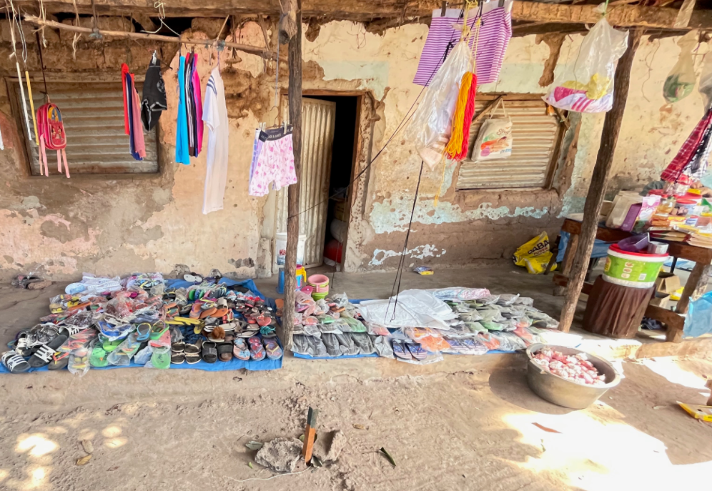
Figure 12. Modern store in front of the remains of a former military building in Tite, Guinea-Bissau, 2023. Photograph by Mustafah Dhada. © Mustafah Dhada. Used with permission.

At a broader level, the history of wartime Tite contributes directly to how one understands counterinsurgency and decolonization. It demonstrates that colonial power operated not only through violence but also through space. The ability to rearrange bodies, influence populations, and control information was just as, if not more important, than killing combatants, downing aircraft, and ambushing patrols; both for the Portuguese and the PAIGC. Tite was as much a psychological and social weapon as it was a physical one. By compelling Guineans to live under Portuguese supervision, the colonial state sought to manufacture loyalty while erasing the autonomy of movement that sustained rural life. In doing so, it turned the village into an instrument of empire.
This thesis also underscores the importance of microhistory in understanding colonial wars. Grand narratives of liberation often obscure the granular realities of daily life. In focusing on one site, this thesis sought to recover the lived texture of the war. The way the abstract political ideas of Lusotropicalism, closed supervision, and counterinsurgency played out in the lives of civilians, soldiers, and prisoners is vital to understanding legacies of colonialism. Tite serves not only as a case study but as a reminder that empire and resistance were and are experienced by individual human beings.
While this thesis made use of a plethora of materials made available through Portuguese and Guinean archives, it is still severely lacking in primary sources. As stated in the introduction, I was unfortunately not able to visit Tite as intended in preparation for this project. Additional oral methodology conducted in Tite is required to better understand it, specifically how Tite transformed in its life before, during, and after the war.
Additionally, archaeological and forensic studies are key to understanding Tite’s role as a prison and killing field. Tite’s garrison, prison, and underground cells are awaiting investigation and information gleaned from them can be used to better understand Portuguese colonialism and counterinsurgent warfare in Guinea-Bissau and, by extension, the rest of the world.
Finally, mass graves containing the victims of both Portuguese and PAIGC killings are almost certainly present in and around Tite. With explicit permission of the locals and the Guinea-Bissau government, these graves should be respectfully and scientifically exhumed both to shed a spotlight on the mass violence and atrocities committed in the area and also to reinter the victims’ remains with the respect and care they deserve.
And, of course, Tite was just one of many aldeamentos scattered throughout wartime Guinea-Bissau, all of which remain severely understudied and could benefit from future research. The architectural, economic, militaristic, philosophic, and sociological nature of colonialism and anti-colonialism, both in the past and the modern age, can be better understood through additional studies of Guinean aldeamentos.
In the end, Tite’s story is not only about a single settlement but about the human costs of empire and liberation in the twentieth century. Its buildings, trees, roads, and fences were the physical embodiment of Portugal’s attempt to hold on to an empire that no longer had a legitimate place in the world. Yet within those same boundaries, Guinean people endured, resisted, and ultimately reclaimed their land and history. Modern Tite stands as a testament to the paradox of modern colonialism: that systems built to control and define human life inevitably expose the limits of power itself. In confronting the colonial ruins still standing in Tite today, one is reminded that decolonization is never a single moment of triumph but a long and ongoing process of understanding and repair.
Tite, small as it was, encapsulates this truth. It was a place where an empire unraveled, where cruelty revealed its own futility, and where the people who suffered most became the creators of the nation that emerged. To study Tite, then, is to study the slow end of an old world and the unsteady birth of a new one. Tite is a microcosm of how colonialism dies and how history endures.

Bibliography

Archival Sources

The following material, stored in the AHM, ANTT, and ADN archives in Lisbon, was digitized and made available for this thesis via the Mustafah Dhada Collection, which consists of roughly 5,000 documents, images, and interviews from these archives.
The material utilized from the INEP archive in Bissau was made available in person and digitized by the author. This collection consists of roughly 1,000 documents and images. At the time of research, this collection was not catalogued. The relevant section of documents was found in the INEP archive, in the fourth room, in the second aisle, on the fifth stand, and in the top three shelves. Care was taken to put the material back where it was found.

Arquivo Histórico Militar (AHM)

AHM, “Actividades da 2.ª Repartição, set. 1965–mai. 1967.”

AHM Divisão 2, Secção 4, Caixa 70, Documento 1.

AHM Divisão 2, Secção 4, Caixa 76, Documento 1.

AHM Divisão 2, Secção 4, Caixa 76, Documento 5.

AHM Divisão 2, Secção 4, Caixa 81, Documento 1.

AHM Divisão 2, Secção 4, Caixa 103, Documento 5.

AHM Divisão 2, Secção 4, Caixa 103, Documento 16.

AHM Divisão 2, Secção 4, Caixa 103, Documento 17.

AHM Divisão 2, Secção 4, Caixa 120, Documento 1.

AHM Divisão 2, Secção 4, Caixa 123, Documento 4.

AHM Divisão 2, Secção 4, Caixa 125, Documento 26.

AHM Divisão 2, Secção 4, Caixa 126, Documento 1.

AHM Divisão 2, Secção 4, Caixa 139, Documento 1.

AHM Divisão 2, Secção 4, Caixa 139, Documento 10.

AHM Divisão 2, Secção 4, Caixa 140, Documento 1.

AHM Divisão 2, Secção 4, Caixa 140, Documento 7.

AHM Divisão 2, Secção 4, Caixa 140, Documento 8.

AHM Divisão 2, Secção 4, Caixa 141, Documento 7.

AHM Divisão 2, Secção 4, Caixa 147, Documento 5.

AHM Divisão 2, Secção 4, Caixa 154, Documento 3.

AHM Divisão 2, Secção 4, Caixa 168, Documento 4.

AHM Divisão 2, Secção 4, Caixa 171, Documento 3.

AHM Divisão 2, Secção 4, Caixa 182, Documento 4.

AHM Divisão 2, Secção 4, Caixa 226, Documento 1.

AHM Divisão 2, Secção 4, Caixa 226, Documento 2.

AHM Divisão 7A, Secção 33, Caixa 53, Documento 8.

AHM Divisão 7A, Secção 33, Caixa 54, Documento 10.

AHM Divisão 7A, Secção 73, Caixa 111, Documento 72.

AHM Divisão 7B, Secção 21, Caixa 305, Documento 11.

AHM Divisão 44, Secção 1, Caixa 844, Documento 4.

Arquivo Nacional da Torre do Tombo (ANTT)

ANTT, Organização dos Serviços, Comissão de Organização do Ultramar, Ref. 23, Caixa 35.

ANTT, Polícia Internacional e de Defesa do Estado / Direcção-Geral de Segurança, Delegação de Angola, Polícia de Repressão, Processo n.º 3684, NT 1061.

ANTT, Polícia Internacional e de Defesa do Estado / Direcção-Geral de Segurança, Delegação de Angola, Secção Regional, Processo n.º 12656, NT 1139.

ANTT, Ref. 5, Polícia Internacional e de Defesa do Estado / Direcção-Geral de Segurança, Delegação de Angola e Lisboa, Gabinete, Processo n.º 3790, NT 8129.

ANTT, Ref. 109, Polícia Internacional e de Defesa do Estado / Direcção-Geral de Segurança, Delegação de Angola e Lisboa, Gabinete, Processo n.º 3792, NT 8129.

ANTT, Ref. 29, Polícia Internacional e de Defesa do Estado / Direcção-Geral de Segurança, Delegação da Guiné, Polícia de Conjuntura, Processo n.º 25654, NT 5857.

ANTT, Ref. 114, Polícia Internacional e de Defesa do Estado / Direcção-Geral de Segurança, Delegação da Guiné, Polícia de Conjuntura, Processo n.º 97/66, NT 5480.

ANTT, Ref. 119, Polícia Internacional e de Defesa do Estado / Direcção-Geral de Segurança, Delegação da Guiné, Polícia de Conjuntura, Processo n.º 584, NT 6069.

ANTT, Ref. 128, Polícia Internacional e de Defesa do Estado / Direcção-Geral de Segurança, Delegação da Guiné, Polícia de Conjuntura, Processo n.º 12/62, NT 5434, Pasta 12.

ANTT, Polícia Internacional e de Defesa do Estado / Direcção-Geral de Segurança, Delegação da Guiné, Polícia de Conjuntura, Processo n.º 172, NT 5574.

ANTT, Polícia Internacional e de Defesa do Estado / Direcção-Geral de Segurança, Delegação da Guiné, Polícia de Conjuntura, Processo n.º 6873, NT 5593.

ANTT, Polícia Internacional e de Defesa do Estado / Direcção-Geral de Segurança, Serviços Centrais, Secção Regional, Processo n.º 1915/50, NT 2677, Pasta 9.

ANTT, Polícia Internacional e de Defesa do Estado / Direcção-Geral de Segurança, Serviços Centrais, Secção de Informação (2.ª Subsecção), Processo n.º 7477, NT 7495, Pasta 16.

ANTT, Ref. 107, Polícia Internacional e de Defesa do Estado / Direcção-Geral de Segurança, Serviços Centrais, Secção Regional, Processo n.º 641/61, NT 3063–3073, Pasta 12.

ANTT, Polícia Internacional e de Defesa do Estado / Direcção-Geral de Segurança, Serviços Centrais, Secção Regional, Ref. 641, Processo n.º 61, Pasta 1.

Arquivo Nacional da Guiné-Bissau (ADN)

ADN, “Guiné: História de Unidade de Engenharia.”

ADN Ref. 6, Secretaria-Geral da Defesa Nacional, 2.ª Repartição, Caixa 106, Documento 410/1.

ADN Ref. 7, Secretaria-Geral da Defesa Nacional, 2.ª Repartição, Caixa 106, Documento 410/2.

ADN Ref. 8, Secretaria-Geral da Defesa Nacional, 2.ª Repartição, Caixa 106, Documento 410/3.

ADN Ref. 9, Secretaria-Geral da Defesa Nacional, 2.ª Repartição, Caixa 106, Documento 410/4.

ADN Ref. 10, Secretaria-Geral da Defesa Nacional, 2.ª Repartição, Caixa 107, Documento 423/1.

ADN Ref. 17, Secretaria-Geral da Defesa Nacional, 2.ª Repartição, Caixa 106, Documento 411/7.

ADN Ref. 19, Secretaria-Geral da Defesa Nacional, 2.ª Repartição, Caixa 106, Documento 412/9.

ADN Ref. 20, Secretaria-Geral da Defesa Nacional, 2.ª Repartição, Caixa 106, Documento 412/10.

ADN Ref. 23, Secretaria-Geral da Defesa Nacional, 2.ª Repartição, Caixa 106, Documento 412/13.

ADN Ref. 25, Secretaria-Geral da Defesa Nacional, 2.ª Repartição, Caixa 106, Documento 413/15.

ADN Ref. 29, Secretaria-Geral da Defesa Nacional, 2.ª Repartição, Caixa 106, Documento 414/19.

ADN Ref. 30, Secretaria-Geral da Defesa Nacional, 2.ª Repartição, Caixa 106, Documento 414/20.

ADN Ref. 34, Secretaria-Geral da Defesa Nacional, 2.ª Repartição, Caixa 106, Documento 415/24.

ADN Ref. 35, Secretaria-Geral da Defesa Nacional, 2.ª Repartição, Caixa 106, Documento 416/25.

ADN Ref. 43, Secretaria-Geral da Defesa Nacional, 2.ª Repartição, Caixa 106, Documento 418/33.

ADN Ref. 44, Secretaria-Geral da Defesa Nacional, 2.ª Repartição, Caixa 106, Documento 419/34.

ADN Ref. 50, Secretaria-Geral da Defesa Nacional, 2.ª Repartição, Caixa 106, Documento 421/40.

ADN Ref. 56, Secretaria-Geral da Defesa Nacional, 2.ª Repartição, Caixa 108, Documento 424/1.

ADN Ref. 121, Fundo 2, 1.ª Repartição, Série 102, Caixa 325, Pasta 6.

ADN Ref. 129, Secretaria-Geral da Defesa Nacional, 2.ª Repartição, Caixa 102, Documento 326/14.

ADN Ref. 130, Fundo 2, 1.ª Repartição, Série 102, Caixa 327, Pasta 15.

ADN Ref. 131, Fundo 2, 1.ª Repartição, Série 102, Caixa 327, Pasta 16.

ADN Ref. 134, Fundo 2, 1.ª Repartição, Série 103, Caixa 328, Pasta 1.

ADN Ref. 135, Secretaria-Geral da Defesa Nacional, 2.ª Repartição, Caixa 103, Documento 328/2.

ADN Ref. 142, 1.ª Repartição, Série 103, Caixa 330, Pasta 9.

Instituto Nacional de Estudos e Pesquisa (INEP)

INEP, “Administração da Circunscrição de Fulacunda, 1967–1968.”

INEP, “Circular de Execução Permanente".

INEP, “Confidenciais Expedida 1960s.”

INEP, “Posto Administrativo de Tite. Livro de Manifestos de Produtos, Líquidos, Oleaginosas e Arroz, 1947-1955”.

INEP, “Tite Telegramas, 1960s.”

INEP, Ilha das Galinhas Prisoner Record No. 475.

INEP, Ilha das Galinhas Prisoner Record No. 531.

INEP, Ilha das Galinhas Prisoner Record No. 563.

INEP, Ilha das Galinhas Prisoner Record No. 713.

Oral Interviews

Benita Mora Abreu. Interview by Rui Aristides Lebre. Tite, Guinea-Bissau, May 3, 2023.

Camare (pseudonym). Interview by Rui Aristides Lebre. Tite, Guinea-Bissau, May 5, 2023.

Mamadu. Interview/biographical profile. “Interview: How Guinea-Bissau’s Anti-colonial Struggle Influenced the Carnation Revolution.” International Forum for Digital Democracy Review (IF DDR). April 25, 2024. Accessed October 17, 2025. https://ifddr.org/en/interview-how-guinea-bissaus-anti-colonial-struggle-influenced-the-carnation-revolution/

Mané, Arafam “N’djamba.” Interview/biographical profile. “O fim da dominação colonial e Biografia do Comandante Arafam ‘N’djamba’ Mané.” Tchogue Blog, November 23, 2016. Accessed October 17, 2025. URL.

Sofia (pseudonym). Interview by Rui Aristides Lebre. Tite, Guinea-Bissau, May 5, 2023.

Non-Archival Primary Sources

Cabral, Amílcar. “Guinea and Cabo Verde against Portuguese Colonialism.” Speech delivered at the Conference of African Peoples, Cairo, March 25–31, 1961. In Marxists Internet Archive. Last modified 2003. https://www.marxists.org/subject/africa/cabral/1961/gcvpc.htm

Constituição Política da República Portuguesa (Revisão de 1951). Lisbon: Imprensa Nacional, 1951.

Freyre, Gilberto. Integração Portuguesa nos Trópicos. Lisbon: Comissão Executiva das Comemorações do V Centenário da Morte do Infante D. Henrique, 1958.

Freyre, Gilberto. O Mundo que o Português Criou. Rio de Janeiro: José Olympio, 1940.

Hobhouse, Emily. Report of a Visit to the Camps of Women and Children in the Cape and Orange River Colonies. London: Friars Printing Association, 1901.

Secondary Sources

Articles and Chapters

Alexandre, Valentim. “Traumas do Império: História, Memória e Identidade Nacional.” Cadernos de Estudos Africanos, no. 9/10 (2005/2006): 23–41.

Amado, Abel Djassi. “The PAIGC ‘Congratulatory’ Diplomacy towards Communist States, 1960–1964.” Lusotopie 19, no. 1 (2020): 54–75. Accessed October 17, 2025. https://journals.openedition.org/lusotopie/4640

Dhada, Mustafah. “The Liberation War in Guinea-Bissau Reconsidered.” The Journal of Military History 62, no. 3 (July 1998): 571–93.

Duarte Silva, António E. “Guiné-Bissau: The Cause of Nationalism and the Foundation of the PAIGC.” Cadernos de Estudos Africanos 9/10 (2006): 142–67. Accessed October 17, 2025. https://journals.openedition.org/cea/1236

Embaló, Birgit. “From Cabral’s Liberation Movement to Power Struggle and Ideological Erosion: The Decline of PAIGC in Guinea-Bissau.” In National Liberation Movements as Government in Africa, edited by Redie Bereketab, 72–88. London: Routledge, 2017.

Gerlach, Christian. “Sustainable Violence: Mass Resettlement, Strategic Villages, and Militias in Anti-Guerrilla Warfare.” In Removing Peoples: Forced Removal in the Modern World, edited by Richard Bessel and Claudia B. Haake, 360–93. Oxford: Oxford University Press, 2009.

Hurley, Matthew M. “The War Is Lost: Technological Surprise and the Collapse of Portugal’s Colonial Airpower Strategy, Guinea 1963–1974.” In Technology, Violence, and War: Essays in Honor of Dr. John F. Guilmartin Jr., edited by Jeremy Black et al., 260–78. Leiden: Brill, 2019. https://doi.org/10.1163/9789004393301_014

Jerónimo, Miguel Bandeira. “Portuguese Colonialism in Africa.” Oxford Research Encyclopedia of African History, March 28, 2018. Accessed October 17, 2025. https://oxfordre.com/africanhistory/view/10.1093/acrefore/9780190277734.001.0001/acrefore-9780190277734-e-183

Lebre, Rui Aristides. “Forced Villagisation in the Global South: Reading Post-war Rural ‘Development’ Through the Lens of Wartime Villagisation in Africa (1950–1980).” The Journal of Imperial and Commonwealth History 52, no. 6 (2024): 908–935. https://doi.org/10.1080/03086534.2024.2445014

Lebre, Rui Aristides. “Managing Luso-Utopia in Guinea-Bissau: Imperial Fictions and Dwelling Practices in Late Portuguese Colonialism (1945–74).” Architectural Histories 12, no. 1 (2024). https://doi.org/10.16995/ah.8544

Milheiro, Ana Vaz. “Wartime Residential Rural Landscapes: The Guinea-Bissau Case during the Colonial-Liberation War with the Portuguese (1963–1974).” Cogent Arts & Humanities 11, no. 1 (2024): 2. https://doi.org/10.1080/23311983.2024.2303184

Reza, Alexandra. “Reading the Radio-Magazine: Culture, Decolonization and the PAIGC’s Rádio Libertação.” Interventions: International Journal of Postcolonial Studies (2021). https://doi.org/10.1080/1369801X.2021.1972821

Ribeiro, Nelson. “Broadcasting to the Portuguese Empire in Africa: Salazar’s Singular Broadcasting Policy.” Critical Arts: South–North Cultural and Media Studies 28, no. 6 (2014): 920–937. https://doi.org/10.1080/02560046.2014.990630

Rodrigues, Fátima da Cruz. “The Demobilization of African Soldiers in the Portuguese Armed Forces during the Colonial War (1961–1974).” Ler História 65 (2013): 113–128. https://doi.org/10.4000/lerhistoria.484

Simpson, Duncan. “Approaching the PIDE ‘From Below’: Petitions, Spontaneous Applications and Denunciation Letters to Salazar’s Secret Police in 1964.” Contemporary European History 30, no. 3 (2021): 398–413. Accessed October 17, 2025. https://doi.org/10.1017/S0960777320000612

Books

Agier, Michel. Managing the Undesirables: Refugee Camps and Humanitarian Government. Translated by David Fernbach. Cambridge, UK: Polity Press, 2011.

Amado, Leopoldo. Guerra Colonial e Guerra de Libertação Nacional (1950–1974): O Caso da Guiné-Bissau. Lisboa: Instituto de Defesa Nacional, 2011.

Arendt, Hannah. On Revolution. New York: Viking Press, 1963.

Borges Coelho, João Paulo. Dictionary of the Portuguese Colonial Wars in Africa (1961–1974). Lisbon: Cadernos de Estudos Africanos, Centro de Estudos Africanos, Instituto Universitário de Lisboa, 2020.

Boxer, Charles R. The Portuguese Seaborne Empire, 1415–1825. New York: Alfred A. Knopf, 1969.

Bruce, Neil. Portugal: The Last Empire. London: David & Charles, 1975.

Cabral, Amílcar. Our People Are Our Mountains: Amílcar Cabral on the Guinean Revolution. London: Committee for Freedom in Mozambique, Angola and Guiné, 1972.

Cabral, Amílcar. Unity and Struggle. Edited by Maurice Taonezvi Vambe and Abebe Zegeye. Translated by Michael Wolfers. Pretoria: UNISA Press, 2004.

Chabal, Patrick. Amílcar Cabral: Revolutionary Leadership and People’s War. Cambridge: Cambridge University Press, 1983.

Chaliand, Gérard. Armed Struggle in Africa: With the Guerrillas in “Portuguese” Guinea. New York: Monthly Review Press, 1969.

Chirot, Daniel, and Clark McCauley. Why Not Kill Them All?: The Logic and Prevention of Mass Political Murder. Princeton, NJ: Princeton University Press, 2006.

Davidson, Basil. No Fist Is Big Enough to Hide the Sky: The Liberation of Guinea-Bissau and Cape Verde, 1963–74. London: Zed Books, 1981.

Dhada, Mustafah. Warriors at Work: How Guinea Was Really Set Free. Boulder, CO: Westview Press, 1993.

Hawthorne, Walter. Planting Rice and Harvesting Slaves: Transformations along the Guinea-Bissau Coast, 1400–1900. Portsmouth, NH: Heinemann, 2003.

Hemming, John. Red Gold: The Conquest of the Brazilian Indians, 1500–1760. Cambridge, MA: Harvard University Press, 1978.

Kramer, Paul A. The Blood of Government: Race, Empire, the United States, and the Philippines. Chapel Hill: University of North Carolina Press, 2006.

Lloyd-Jones, Stewart, and António Costa Pinto. The Last Empire: Thirty Years of Portuguese Decolonization. Portland, OR: Intellect Books, 2003.

Ly, Aliou. Women of the Portuguese Guinea Liberation War: De-gendering the History of Anticolonial Struggle. London: Zed Books / Bloomsbury, 2024.

Newitt, Malyn. A History of Portuguese Overseas Expansion, 1400–1668. London: Routledge, 2005.

Prucha, Francis Paul. The Great Father: The United States Government and the American Indians. Vol. 1. Lincoln: University of Nebraska Press, 1984.

Ramos, Rui, Bernardo Vasconcelos e Sousa, and Nuno Gonçalo Monteiro. História de Portugal. Lisbon: A Esfera dos Livros, 2010.

Spínola, António de. Portugal e o Futuro. Lisboa: Arcádia, 1974.

Tone, John Lawrence. War and Genocide in Cuba, 1895–1898. Chapel Hill: University of North Carolina Press, 2006.

Turner, Victor. The Ritual Process: Structure and Anti-Structure. Chicago: Aldine Publishing, 1969.

United Nations. Yearbook of the United Nations, 1974. New York: Office of Public Information, 1976.

Urdang, Stephanie. Fighting Two Colonialisms: Women in Guinea-Bissau. New York: Monthly Review Press, 1979.

Government and International Organization Documents

Amnesty International. Workshop on Human Rights: Report and Recommendations. London: Amnesty International Publications, 1975.

Dhada, Mustafah. “The Portuguese Military Garrison of Tite: An Incomplete History, 1950–2020.” Paper presented at the panel Guinea-Bissau 50 Years After Independence: New Perspectives on Liberation and Its Aftermath, Lusophone African Studies Organization, African Studies Association Annual Meeting, Chicago, December 14, 2024. Accessed December 24, 2024.

Organization of African Unity. Resolutions and Statement of the Nineteenth Ordinary Session of the Council of Ministers Held in Rabat, Morocco from 5 to 12 June 1972. CM/Res. 268 (XIX). Rabat: OAU, 1972. https://au.int/web/sites/default/files/decisions/9581-council_en_5_12_june_1972_council_ministers_nineteenth_ordinary_session.pdf

United Nations. Summary Record of the 849th Meeting of the Special Committee on the Situation with Regard to the Implementation of the Declaration on the Granting of Independence to Colonial Countries and Peoples, Conakry, 11 April 1972. A/AC.109/SR.849.

United Nations General Assembly. Report of the Special Mission Established by the Special Committee on the Situation with Regard to the Implementation of the Declaration on the Granting of Independence to Colonial Countries and Peoples. A/AC.109/L.804. July 3, 1972.

United Nations General Assembly. Resolution 2918 (XXVII). “Question of Territories under Portuguese Administration.” December 4, 1972.

U.S. Department of State. 2021 Report on International Religious Freedom: Guinea-Bissau. Washington, D.C.: U.S. Department of State, 2021. Accessed October 17, 2025. https://www.state.gov/reports/2021-report-on-international-religious-freedom/guinea-bissau/

U.S. Embassy (Lisbon). Airgram A-172: “Moment of Truth Drawing Near in Portuguese Guinea?”, September 11, 1973. In Foreign Relations of the United States, 1969–1976, Volume E-6, Documents on Africa, 1973–1976, Document 67. Washington, D.C.: Office of the Historian, U.S. Department of State.

Maps and Photographs

Câmara, José da. Soldier Next to Cross Stele, Tite, Portuguese Guinea. Photograph, December 1972. Reproduced in Blogue Força Aérea, Não Há Guerra Como Esta, July 25, 2011. © José da Câmara. https://blogueforanadaevaotres.blogspot.com/2011/07/guine-6374-p8597-memorias-e-historias.html

Carvalho, João. PAIGC Checkpoint in Guinea-Bissau after the Declaration of Independence. Photograph, 1974. Courtesy of Wikimedia Commons. © Public domain (via Wikimedia Commons). https://commons.wikimedia.org/wiki/File:PAIGC_posto_de_controlo.jpg

Correia dos Santos. Aerial View of Tite, Portuguese Guinea. Photograph, c. 1960s–1970s. Reproduced in “Bela Foto de Tite, do Correia dos Santos.” Bart 1914 (blog), January 30, 2018. © Correia dos Santos. https://bart1914.blogspot.com/2018/01/bela-foto-de-tite-do-correia-dos-santos.html

Coutinho, Roel. Wreckage of a Portuguese Aircraft, Guinea-Bissau. Photograph, 1974. Courtesy of the Coutinho Collection. © Public domain (via Wikimedia Commons). https://commons.wikimedia.org/wiki/File:ASC_Leiden_-_Coutinho_Collection_-_7_26_-_Portuguese_plane_shot_down_in_Guinea-Bissau_-_1974.tif

Dhada, Mustafah. Entrance to an Underground Cell in Tite, Guinea-Bissau. Photograph, 2023. © Mustafah Dhada. Used with permission.

Dhada, Mustafah. Modern Store in Front of the Remains of a Former Military Building in Tite, Guinea-Bissau. Photograph, 2023. © Mustafah Dhada. Used with permission.

Galvão, Henrique. Portugal n’est pas un petit pays (“Portugal Is Not a Small Country”). Map, 1934. © Biblioteca Nacional de Portugal.

Luís Graça & Camaradas da Guiné. “Bissássema, Tite Region, 10 March 1968 — Destruction of the Village by Portuguese Troops (CCAÇ 2314).” Luís Graça & Camaradas da Guiné (blog), May 30, 2025. © Luís Graça & Camaradas da Guiné Blog. https://blogueforanadaevaotres.blogspot.com/2025/05/guine-6174-p26863-casos-verdade-sobre.html

PAIGC (Partido Africano para a Independência da Guiné e Cabo Verde). Guerrillas on the Move in the Bush, Guinea-Bissau. Photograph, n.d. Reproduced in Mikael Levin – Cristina’s History. Cherbourg-Octeville: Le Point du Jour; Lisbon: Museu Colecção Berardo, 2009, 91. © PAIGC. Accessed via Luís Graça & Camaradas da Guiné (blog), March 16, 2010. https://blogueforanadaevaotres.blogspot.com/2010_03_28_archive.html

Santos Oliveira. Sergeants’ Mess, Tite, Portuguese Guinea. Photograph, c. 1960s–1970s. Reproduced in Blogue Força Aérea, Não Há Guerra Como Esta, February 27, 2008. © Santos Oliveira. https://blogueforanadaevaotres.blogspot.com/2008/02/guin-6374-p2504-o-bca1860-o-3-bat-em.html

Silva, Aníbal José da. Sergeants’ Room, Tite, Portuguese Guinea. Photograph, 1969–1970. Reproduced in Blogue Luís Graça & Camaradas da Guiné, 2025. © Aníbal José da Silva, CCav 2483/BCav 2867. https://blogueforanadaevaotres.blogspot.com/2025/06/guine-6174-p26884-scem-comentarios-70-o.html

Ware, Daniel. Pidjiguiti Massacre Memorial, Guinea-Bissau. Photograph, May 2025. © Daniel Ware.

Newspapers and Periodicals

Carvalho. “Guiné: Laboratório socio-político no mundo português.” Expresso Revista, no. 13 (1973).

Jornal Nô Pintcha (Bissau). “Statement by a PAIGC Spokesman on Executed Former Portuguese Soldiers.” November 29, 1980.

Theses and Dissertations

Amado, Leopoldo. “Da Embriologia Nacionalista à Guerra de Libertação na Guiné-Bissau.” Didinho.org. Accessed October 17, 2025. https://www.didinho.org/Arquivo/daembriologianacionalista.htm

Campino, Camila Lopes. Espaços e Políticas Prisionais no Império Português: Entre o Encerramento e a Reabertura do Tarrafal (1954–1961). Master’s diss., Universidade Nova de Lisboa, 2018.

Davidson, Joanna. Feet in the Fire: Social Change and Continuity among the Diola of Guinea-Bissau. PhD diss., Emory University, 2007.

Hurley, Matthew M. Sanctuary Lost: The Air War for “Portuguese” Guinea, 1963–1974. Master’s thesis, U.S. Air Force Command and Staff College, 2008.

Moreira, Carlos Eduardo Milho. Discursos e representações dos africanos pelos militares portugueses durante a Guerra Colonial. M.A. thesis, Universidade Nova de Lisboa, 2020.

Websites, Blogs, and Online Resources

Amado, Leopoldo. “Diapasão e Persistências Temáticas na Novíssima Literatura de Guerra Colonial: O Caso da Guiné-Bissau.” Luís Graça & Camaradas da Guiné (blog), October 5, 2008. https://blogueforanadaevaotres.blogspot.com/2008/10/guin-6374-p3272-novssima-literatura-da.html

CCaç 2314. Facebook page. Featuring photographs and recollections of Portuguese military service in Guinea-Bissau during the 1960s–1970s. Accessed October 26, 2025. https://www.facebook.com/profile.php?id=100080276350898&locale=pt_PT

“Guinea-Bissau.” Oxford Research Encyclopedia of African History. Accessed October 17, 2025. https://oxfordre.com/africanhistory/display/10.1093/acrefore/9780190277734.001.0001/acrefore-9780190277734-e-425

International Forum for Digital Democracy Review (IF DDR). “Interview: How Guinea-Bissau’s Anti-colonial Struggle Influenced the Carnation Revolution.” April 25, 2024. Accessed October 17, 2025. https://ifddr.org/en/interview-how-guinea-bissaus-anti-colonial-struggle-influenced-the-carnation-revolution/

Intelectuais Balantas Na Diáspora. “O fim da dominação colonial e Biografia do Comandante Arafam ‘N’djamba’ Mané.” Intelectuais Balantas Na Diáspora (blog), November 23, 2016. https://tchogue.blogspot.com/2016/11/o-fim-da-dominacao-colonial-e-biografia.html

Luís Graça & Camaradas da Guiné. Blogue Força Aérea e Outros (blog). Accessed October 26, 2025. https://blogueforanadaevaotres.blogspot.com/

Gilberto Freyre, O Mundo que o Português Criou (Rio de Janeiro: José Olympio, 1940), 32–33.
Gilberto Freyre, Integração Portuguesa nos Trópicos (Lisbon: Comissão Executiva das Comemorações do V Centenário da Morte do Infante D. Henrique, 1958), 9.
Constituição Política da República Portuguesa (Revisão de 1951) (Lisbon: Imprensa Nacional, 1951).
Henrique Galvão, Portugal não é um país pequeno [map] (Lisbon: Agência Geral das Colónias, 1934).
AHM Divisão 2, Secção 4, Caixa 140, Documento 1.
AHM Divisão 2, Secção 4, Caixa 140, Documento 1.
Matthew M. Hurley, “The War Is Lost: Technological Surprise and the Collapse of Portugal’s Colonial Airpower Strategy, Guinea 1963–1974,” in Technology, Violence, and War: Essays in Honor of Dr. John F. Guilmartin Jr., ed. Jeremy Black et al. (Leiden: Brill, 2019), 260–278, https://doi.org/10.1163/9789004393301_014
Mustafah Dhada, “The Liberation War in Guinea-Bissau Reconsidered,” The Journal of Military History 62, no. 3 (July 1998): 571–93.
ADN Ref. 34, Secretaria-Geral da Defesa Nacional, 2.ª Repartição, Caixa 106, Documento 415/24.
ANTT, PIDE/DGS, Serviços Centrais, Secção Regional, Processo n.º 1915/50, NT 2677, Pasta 9.
AHM Divisão 2, Secção 4, Caixa 226, Documento 1.
AHM Divisão 7A, Secção 33, Caixa 53, Documento 8.
AHM Divisão 2, Secção 4, Caixa 70, Documento 1.
AHM Divisão 7A, Secção 33, Caixa 54, Documento 10.
AHM Divisão 2, Secção 4, Caixa 141, Documento 7.
ADN Ref. 121, Fundo 2, 1.ª Repartição, Série 102, Caixa 325, Pasta 6.
AHM Divisão 2, Secção 4, Caixa 103, Documento 5.
ADN Ref. 29, Secretaria-Geral da Defesa Nacional, 2.ª Repartição, Caixa 106, Documento 414/19.
Gérard Chaliand, Armed Struggle in Africa: With the Guerrillas in “Portuguese” Guinea (New York: Monthly Review Press, 1969), 26.
AHM Divisão 7B, Secção 21, Caixa 305, Documento 11.
AHM Divisão 2, Secção 4, Caixa 103, Documento 5.
AHM Divisão 2, Secção 4, Caixa 226, Documento 1.
AHM Divisão 2, Secção 4, Caixa 126, Documento 1.
AHM Divisão 2, Secção 4, Caixa 123, Documento 4.
AHM Divisão 2, Secção 4, Caixa 126, Documento 1.
Rui Aristides Lebre, “Forced Villagisation in the Global South: Reading Post-war Rural ‘Development’ Through the Lens of Wartime Villagisation in Africa (1950–1980),” The Journal of Imperial and Commonwealth History 52, no. 6 (2024): https://doi.org/10.1080/03086534.2024.2445014
INEP, “Administração da Circunscrição de Fulacunda, 1967–1968.”
Ana Vaz Milheiro, “Wartime Residential Rural Landscapes: The Guinea-Bissau Case during the Colonial-Liberation War with the Portuguese (1963–1974),” Cogent Arts & Humanities 11, no. 1 (2024), https://doi.org/10.1080/23311983.2024.2303184
CCaç 2314, Facebook page, featuring photographs and recollections of Portuguese military service in Guinea-Bissau during the 1960s–1970s. Accessed October 26, 2025. https://www.facebook.com/profile.php?id=100080276350898&locale=pt_PT
Ana Vaz Milheiro, “Wartime Residential Rural Landscapes: The Guinea-Bissau Case during the Colonial-Liberation War with the Portuguese (1963–1974),” Cogent Arts & Humanities 11, no. 1 (2024): 8, https://doi.org/10.1080/23311983.2024.2303184
Carvalho, “Guiné: Laboratório socio-político no mundo português,” Expresso Revista, no. 13 (1973).
Ana Vaz Milheiro, “Wartime Residential Rural Landscapes: The Guinea-Bissau Case during the Colonial-Liberation War with the Portuguese (1963–1974),” Cogent Arts & Humanities 11, no. 1 (2024): 16, https://doi.org/10.1080/23311983.2024.2303184
Ana Vaz Milheiro, “Wartime Residential Rural Landscapes: The Guinea-Bissau Case during the Colonial-Liberation War with the Portuguese (1963–1974),” Cogent Arts & Humanities 11, no. 1 (2024): 16, https://doi.org/10.1080/23311983.2024.2303184
ADN, “Guiné: História de Unidade de Engenharia.”
ADN, “Guiné: História de Unidade de Engenharia.”
ADN, “Guiné: História de Unidade de Engenharia.”
ADN, “Guiné: História de Unidade de Engenharia.”
Rui Aristides Lebre, “Forced Villagisation in the Global South: Reading Post-war Rural ‘Development’ Through the Lens of Wartime Villagisation in Africa (1950–1980),” The Journal of Imperial and Commonwealth History 52, no. 6 (2024), https://doi.org/10.1080/03086534.2024.2445014
AHM Divisão 2, Secção 4, Caixa 226, Documento 2.
Rui Ramos, Bernardo Vasconcelos e Sousa, and Nuno Gonçalo Monteiro, História de Portugal (Lisbon: A Esfera dos Livros, 2010).
AHM Divisão 2, Secção 4, Caixa 182, Documento 4.
AHM Divisão 2, Secção 4, Caixa 182, Documento 4.
Ana Vaz Milheiro, “Wartime Residential Rural Landscapes: The Guinea-Bissau Case during the Colonial-Liberation War with the Portuguese (1963–1974),” Cogent Arts & Humanities 11, no. 1 (2024): 5, https://doi.org/10.1080/23311983.2024.2303184
Gérard Chaliand, Armed Struggle in Africa: With the Guerrillas in “Portuguese” Guinea (New York: Monthly Review Press, 1969), 74.
AHM Divisão 44, Secção 1, Caixa 844, Documento 4.
John Hemming, Red Gold: The Conquest of the Brazilian Indians, 1500–1760 (Cambridge, MA: Harvard University Press, 1978), 35–44.
Daniel Chirot and Clark McCauley, Why Not Kill Them All?: The Logic and Prevention of Mass Political Murder (Princeton, NJ: Princeton University Press, 2006), 21.
Francis Paul Prucha, The Great Father: The United States Government and the American Indians, vol. 1 (Lincoln: University of Nebraska Press, 1984), 212–225.
Paul A. Kramer, The Blood of Government: Race, Empire, the United States, and the Philippines (Chapel Hill: University of North Carolina Press, 2006), 138–142.
Ana Vaz Milheiro, “Wartime Residential Rural Landscapes: The Guinea-Bissau Case during the Colonial-Liberation War with the Portuguese (1963–1974),” Cogent Arts & Humanities 11, no. 1 (2024): 2, https://doi.org/10.1080/23311983.2024.2303184
Ana Vaz Milheiro, “Wartime Residential Rural Landscapes: The Guinea-Bissau Case during the Colonial-Liberation War with the Portuguese (1963–1974),” Cogent Arts & Humanities 11, no. 1 (2024): 2, https://doi.org/10.1080/23311983.2024.2303184
Rui Aristides Lebre, “Managing Luso-Utopia in Guinea-Bissau: Imperial Fictions and Dwelling Practices in Late Portuguese Colonialism (1945–74),” Architectural Histories 12, no. 1 (2024), https://doi.org/10.16995/ah.8544
Rui Aristides Lebre, “Managing Luso-Utopia in Guinea-Bissau: Imperial Fictions and Dwelling Practices in Late Portuguese Colonialism (1945–74),” Architectural Histories 12, no. 1 (2024): 9, https://doi.org/10.16995/ah.8544
Ana Vaz Milheiro, “Wartime Residential Rural Landscapes: The Guinea-Bissau Case during the Colonial-Liberation War with the Portuguese (1963–1974),” Cogent Arts & Humanities 11, no. 1 (2024), https://doi.org/10.1080/23311983.2024.2303184
Christian Gerlach, “Sustainable Violence: Mass Resettlement, Strategic Villages, and Militias in Anti-Guerrilla Warfare,” in Removing Peoples: Forced Removal in the Modern World, ed. Richard Bessel and Claudia B. Haake (Oxford: Oxford University Press, 2009), 360–93.
AHM Divisão 2, Secção 4, Caixa 226, Documento 1.
INEP, “Tite Telegramas, 1960s.”
ADN Ref. 56, Secretaria-Geral da Defesa Nacional, 2.ª Repartição, Caixa 108, Documento 424/1.
AHM Divisão 2, Secção 4, Caixa 76, Documento 1.
AHM Divisão 2, Secção 4, Caixa 141, Documento 7.
INEP, “Administração da Circunscrição de Fulacunda, 1967–1968.”
INEP, “Administração da Circunscrição de Fulacunda, 1967–1968.”
ADN Ref. 142, 1.ª Repartição, Série 103, Caixa 330, Pasta 9
Leopoldo Amado, Guerra Colonial e Guerra de Libertação Nacional (1950–1974): O Caso da Guiné-Bissau (Lisboa: Instituto de Defesa Nacional, 2011).
Leopoldo Amado, Guerra Colonial e Guerra de Libertação Nacional (1950–1974): O Caso da Guiné-Bissau (Lisboa: Instituto de Defesa Nacional, 2011).
ADN Ref. 134, Fundo 2, 1.ª Repartição, Série 103, Caixa 328, Pasta 1.
ADN Ref. 130, Fundo 2, 1.ª Repartição, Série 102, Caixa 327, Pasta 15.
Amílcar Cabral, Our People Are Our Mountains: Amílcar Cabral on the Guinean Revolution (London: Committee for Freedom in Mozambique, Angola and Guiné, 1972), 4.
Mustafah Dhada, Warriors at Work: How Guinea Was Really Set Free (Boulder, CO: Westview Press, 1993).
Leopoldo Amado, Guerra Colonial e Guerra de Libertação Nacional (1950–1974): O Caso da Guiné-Bissau (Lisboa: Instituto de Defesa Nacional, 2011).
ADN Ref. 130, Fundo 2, 1.ª Repartição, Série 102, Caixa 327, Pasta 15.
ADN Ref. 30, Secretaria-Geral da Defesa Nacional, 2.ª Repartição, Caixa 106, Documento 414/20.
Joanna Davidson, Feet in the Fire: Social Change and Continuity among the Diola of Guinea-Bissau (PhD diss., Emory University, 2007).
INEP, “Confidenciais Expedida 1960s.”
ANTT, PIDE/DGS, Serviços Centrais, Secção de Informação (2.ª Subsecção), Processo n.º 7477, NT 7495, Pasta 16.
Gérard Chaliand, Armed Struggle in Africa: With the Guerrillas in “Portuguese” Guinea (New York: Monthly Review Press, 1969), 14.
Gérard Chaliand, Armed Struggle in Africa: With the Guerrillas in “Portuguese” Guinea (New York: Monthly Review Press, 1969), 17.
Gérard Chaliand, Armed Struggle in Africa: With the Guerrillas in “Portuguese” Guinea (New York: Monthly Review Press, 1969), 63.
Stephanie Urdang, Fighting Two Colonialisms: Women in Guinea-Bissau (New York: Monthly Review Press, 1979).
Gérard Chaliand, Armed Struggle in Africa: With the Guerrillas in “Portuguese” Guinea (New York: Monthly Review Press, 1969), 63.
Gérard Chaliand, Armed Struggle in Africa: With the Guerrillas in “Portuguese” Guinea (New York: Monthly Review Press, 1969), 64.
U.S. Embassy (Lisbon), Airgram A-172: “Moment of Truth Drawing Near in Portuguese Guinea?”, September 11 1973, in Foreign Relations of the United States, 1969-1976, Volume E-6, Documents on Africa, 1973-1976, Document 67, Office of the Historian, U.S. Department of State.
Mustafah Dhada, “The Portuguese Military Garrison of Tite: An Incomplete History, 1950–2020,” paper presented at the panel Guinea-Bissau 50 Years After Independence: New Perspectives on Liberation and Its Aftermath, Lusophone African Studies Organization, African Studies Association Annual Meeting, Chicago, December 14, 2024, accessed December 24, 2024.
Mustafah Dhada, “The Portuguese Military Garrison of Tite: An Incomplete History, 1950–2020,” paper presented at the panel Guinea-Bissau 50 Years After Independence: New Perspectives on Liberation and Its Aftermath, Lusophone African Studies Organization, African Studies Association Annual Meeting, Chicago, December 14, 2024, accessed December 24, 2024.
Mustafah Dhada, “The Portuguese Military Garrison of Tite: An Incomplete History, 1950–2020,” paper presented at the panel Guinea-Bissau 50 Years After Independence: New Perspectives on Liberation and Its Aftermath, Lusophone African Studies Organization, African Studies Association Annual Meeting, Chicago, December 14, 2024, accessed December 24, 2024.
Mustafah Dhada, “The Portuguese Military Garrison of Tite: An Incomplete History, 1950–2020,” paper presented at the panel Guinea-Bissau 50 Years After Independence: New Perspectives on Liberation and Its Aftermath, Lusophone African Studies Organization, African Studies Association Annual Meeting, Chicago, December 14, 2024, accessed December 24, 2024.
U.S. Department of State, 2021 Report on International Religious Freedom: Guinea-Bissau (Washington, D.C.: U.S. Department of State, 2021), accessed October 17, 2025, https://www.state.gov/reports/2021-report-on-international-religious-freedom/guinea-bissau/
AHM Divisão 2, Secção 4, Caixa 168, Documento 4.
CCaç 2314, Facebook page, featuring photographs and recollections of Portuguese military service in Guinea-Bissau during the 1960s–1970s. Accessed October 26, 2025. https://www.facebook.com/profile.php?id=100080276350898&locale=pt_PT
Rui Aristides Lebre, “Forced Villagisation in the Global South: Reading Post-war Rural ‘Development’ Through the Lens of Wartime Villagisation in Africa (1950–1980),” The Journal of Imperial and Commonwealth History 52, no. 6 (2024): 919, https://doi.org/10.1080/03086534.2024.2445014
Luís Graça & Camaradas da Guiné, Blogue Força Aérea e Outros (blog), accessed October 26, 2025, https://blogueforanadaevaotres.blogspot.com/
Rui Aristides Lebre, “Forced Villagisation in the Global South: Reading Post-war Rural ‘Development’ Through the Lens of Wartime Villagisation in Africa (1950–1980),” The Journal of Imperial and Commonwealth History 52, no. 6 (2024): 916, https://doi.org/10.1080/03086534.2024.2445014
INEP, “Confidenciais Expedida 1960s.”
ADN Ref. 142, 1.ª Repartição, Série 103, Caixa 330, Pasta 9.
AHM Divisão 2, Secção 4, Caixa 76, Documento 5.
ADN Ref. 34, Fundo 2, Secretaria-Geral da Defesa Nacional, 2.ª Repartição, Caixa 106, Documento 415/24.
AHM Divisão 2, Secção 4, Caixa 226, Documento 2.
AHM Divisão 2, Secção 4, Caixa 140, Documento 8.
António de Spínola, Portugal e o Futuro (Lisboa: Arcádia, 1974), 127–128.
AHM Divisão 2, Secção 4, Caixa 140, Documento 7.
AHM Divisão 2, Secção 4, Caixa 140, Documento 8.
AHM Divisão 2, Secção 4, Caixa 140, Documento 8.
AHM Divisão 2, Secção 4, Caixa 141, Documento 7.
Ana Vaz Milheiro, “Wartime Residential Rural Landscapes: The Guinea-Bissau Case during the Colonial-Liberation War with the Portuguese (1963–1974),” Cogent Arts & Humanities 11, no. 1 (2024): 7, https://doi.org/10.1080/23311983.2024.2303184
INEP, “Confidenciais Expedida 1960s.”
INEP, “Tite Telegramas, 1960s.”
ADN Ref. 142, Fundo 2, 1.ª Repartição, Série 103, Caixa 330, Pasta 9.
ANTT, PIDE/DGS, Delegação da Guiné, Polícia de Conjuntura, Processo n.º 6873, NT 5593.
Rui Aristides Lebre, “Forced Villagisation in the Global South: Reading Post-war Rural ‘Development’ Through the Lens of Wartime Villagisation in Africa (1950–1980),” The Journal of Imperial and Commonwealth History 52, no. 6 (2024): 919, https://doi.org/10.1080/03086534.2024.2445014
Walter Hawthorne, Planting Rice and Harvesting Slaves: Transformations along the Guinea-Bissau Coast, 1400-1900 (Portsmouth, NH: Heinemann, 2003), 2.
INEP, “Confidenciais Expedida 1960s.”
ADN Ref. 9, Secretaria-Geral da Defesa Nacional, 2.ª Repartição, Caixa 106, Documento 410/4.
AHM Divisão 2, Secção 4, Caixa 103, Documento 17.
ADN Ref. 17, Secretaria-Geral da Defesa Nacional, 2.ª Repartição, Caixa 106, Documento 411/7.
ADN Ref. 135, Secretaria-Geral da Defesa Nacional, 2.ª Repartição, Caixa 103, Documento 328/2.
ADN Ref. 19, Secretaria-Geral da Defesa Nacional, 2.ª Repartição, Caixa 106, Documento 412/9.
ADN Ref. 129, Secretaria-Geral da Defesa Nacional, 2.ª Repartição, Caixa 102, Documento 326/14.
ADN Ref. 29, Secretaria-Geral da Defesa Nacional, 2.ª Repartição, Caixa 106, Documento 414/19.
AHM Divisão 2, Secção 4, Caixa 140, Documento 8.
AHM Divisão 2, Secção 4, Caixa 171, Documento 3.
AHM Divisão 2, Secção 4, Caixa 125, Documento 26.
AHM Divisão 2, Secção 4, Caixa 154, Documento 3.
AHM Divisão 7A, Secção 73, Caixa 111, Documento 72.
ADN Ref. 50, Secretaria-Geral da Defesa Nacional, 2.ª Repartição, Caixa 106, Documento 421/40.
Matthew M. Hurley, Sanctuary Lost: The Air War for “Portuguese” Guinea, 1963–1974 (master’s thesis, U.S. Air Force Command and Staff College, 2008).
Matthew M. Hurley, Sanctuary Lost: The Air War for “Portuguese” Guinea, 1963–1974 (master’s thesis, U.S. Air Force Command and Staff College, 2008), 78.
ADN Ref. 131, Fundo 2, 1.ª Repartição, Série 102, Caixa 327, Pasta 16.
AHM Divisão 2, Secção 4, Caixa 123, Documento 4.
AHM, “Actividades da 2.ª Repartição, set. 1965–mai. 1967.”
AHM Divisão 2, Secção 4, Caixa 70, Documento 1.
AHM Divisão 2, Secção 4, Caixa 103, Documento 16.
AHM Divisão 2, Secção 4, Caixa 81, Documento 1.
AHM Divisão 2, Secção 4, Caixa 125, Documento 26.
AHM Divisão 2, Secção 4, Caixa 120, Documento 1.
Rui Aristides Lebre, “Forced Villagisation in the Global South: Reading Post-war Rural ‘Development’ Through the Lens of Wartime Villagisation in Africa (1950–1980),” The Journal of Imperial and Commonwealth History 52, no. 6 (2024): 919, https://doi.org/10.1080/03086534.2024.2445014
AHM Divisão 7A, Secção 33, Caixa 54, Documento 10.
AHM Divisão 7A, Secção 33, Caixa 54, Documento 10.
AHM Divisão 44, Secção 1, Caixa 844, Documento 4.
AHM Divisão 2, Secção 4, Caixa 226, Documento 1.
ANTT, AOS/CO/UL, Ref. 23, Caixa 35.
ANTT, AOS/CO/UL, Ref. 23, Caixa 35.
Alexandra Reza, “Reading the Radio-Magazine: Culture, Decolonization and the PAIGC’s Rádio Libertação,” Interventions: International Journal of Postcolonial Studies (2021), https://doi.org/10.1080/1369801X.2021.1972821
Alexandra Reza, “Reading the Radio-Magazine: Culture, Decolonization and the PAIGC’s Rádio Libertação,” Interventions: International Journal of Postcolonial Studies (2021), https://doi.org/10.1080/1369801X.2021.1972821
Alexandra Reza, “Reading the Radio-Magazine: Culture, Decolonization and the PAIGC’s Rádio Libertação,” Interventions: International Journal of Postcolonial Studies (2021): 12, https://doi.org/10.1080/1369801X.2021.1972821
AHM Divisão 44, Secção 1, Caixa 844, Documento 4.
Amílcar Cabral, Unity and Struggle, trans. Michael Wolfers, ed. Maurice Taonezvi Vambe and Abebe Zegeye (Pretoria: UNISA Press, 2004).
Nelson Ribeiro, “Broadcasting to the Portuguese Empire in Africa: Salazar’s Singular Broadcasting Policy,” Critical Arts: South–North Cultural and Media Studies 28, no. 6 (2014): 920–937, https://doi.org/10.1080/02560046.2014.990630
Nelson Ribeiro, “Broadcasting to the Portuguese Empire in Africa: Salazar’s Singular Broadcasting Policy,” Critical Arts: South–North Cultural and Media Studies 28, no. 6 (2014): 920–937, https://doi.org/10.1080/02560046.2014.990630
AHM Divisão 7A, Secção 33, Caixa 54, Documento 10.
Alexandra Reza, “Reading the Radio-Magazine: Culture, Decolonization and the PAIGC’s Rádio Libertação,” Interventions: International Journal of Postcolonial Studies (2021), https://doi.org/10.1080/1369801X.2021.1972821
ADN Ref. 29, Secretaria-Geral da Defesa Nacional, 2.ª Repartição, Caixa 106, Documento 414/19.
AHM Divisão 2, Secção 4, Caixa 154, Documento 3.
INEP, “Confidenciais Expedida 1960s.”
ANTT, AOS/CO/UL, Ref. 23, Caixa 35.
INEP, “Circular de Execução Permanente.”
AHM Divisão 2, Secção 4, Caixa 168, Documento 4.
INEP, “Confidenciais Expedida 1960s.”
INEP, “Administração da Circunscrição de Fulacunda, 1967–1968.”
ANTT, Ref. 107, PIDE/DGS, Serviços Centrais, Secção Regional, Processo n.º 641/61, NT 3063–3073, Pasta 12.
Luís Graça & Camaradas da Guiné, Blogue Força Aérea e Outros (blog), accessed October 26, 2025, https://blogueforanadaevaotres.blogspot.com/
Luís Graça & Camaradas da Guiné, Blogue Força Aérea e Outros (blog), accessed October 26, 2025, https://blogueforanadaevaotres.blogspot.com/
Fátima da Cruz Rodrigues, “The Demobilization of African Soldiers in the Portuguese Armed Forces during the Colonial War (1961-1974),” Ler História 65 (2013): 113–128, doi:10.4000/lerhistoria.484.
Fátima da Cruz Rodrigues, “The Demobilization of African Soldiers in the Portuguese Armed Forces during the Colonial War (1961-1974),” Ler História 65 (2013): 113–128, doi:10.4000/lerhistoria.484.
ANTT, PIDE/DGS, Delegação da Guiné, Polícia de Conjuntura, Processo n.º 172, NT 5574.
ANTT, PIDE/DGS, Delegação da Guiné, Polícia de Conjuntura, Processo n.º 172, NT 5574.
Michel Agier, Managing the Undesirables: Refugee Camps and Humanitarian Government, trans. David Fernbach (Cambridge, UK: Polity Press, 2011).
INEP, “Confidenciais Expedida 1960s.”
INEP, “Confidenciais Expedida 1960s.”
International Forum for Digital Democracy Review (IF DDR), “Interview: How Guinea-Bissau’s Anti-colonial Struggle Influenced the Carnation Revolution,” April 25, 2024, accessed October 17, 2025, https://ifddr.org/en/interview-how-guinea-bissaus-anti-colonial-struggle-influenced-the-carnation-revolution/
Rui Aristides Lebre, “Forced Villagisation in the Global South: Reading Post-war Rural ‘Development’ Through the Lens of Wartime Villagisation in Africa (1950–1980),” The Journal of Imperial and Commonwealth History 52, no. 6 (2024): 917, https://doi.org/10.1080/03086534.2024.2445014
Rui Aristides Lebre, “Forced Villagisation in the Global South: Reading Post-war Rural ‘Development’ Through the Lens of Wartime Villagisation in Africa (1950–1980),” The Journal of Imperial and Commonwealth History 52, no. 6 (2024): 921, https://doi.org/10.1080/03086534.2024.2445014
Mustafah Dhada, Warriors at Work: How Guinea Was Really Set Free (Boulder, CO: Westview Press, 1993), 122.
ADN Ref. 7, Secretaria-Geral da Defesa Nacional, 2.ª Repartição, Caixa 106, Documento 410/2.
ANTT, Ref. 29, PIDE/DGS, Delegação da Guiné, Polícia Internacional, Processo n.º 25654, NT 5857.
ADN Ref. 44, Secretaria-Geral da Defesa Nacional, 2.ª Repartição, Caixa 106, Documento 419/34.
ADN Ref. 6, Secretaria-Geral da Defesa Nacional, 2.ª Repartição, Caixa 106, Documento 410/1.
ANTT, Ref. 114, PIDE/DGS, Subdelegação da Guiné, Polícia de Conjuntura, Processo n.º 97/66, NT 5480.
INEP, “Confidenciais Expedida 1960s.”
Leopoldo Amado, “Diapasão e Persistências Temáticas na Novíssima Literatura de Guerra Colonial: O Caso da Guiné-Bissau,” Luís Graça & Camaradas da Guiné (blog), October 5, 2008, https://blogueforanadaevaotres.blogspot.com/2008/10/guin-6374-p3272-novssima-literatura-da.html
Rui Aristides Lebre, “Forced Villagisation in the Global South: Reading Post-war Rural ‘Development’ Through the Lens of Wartime Villagisation in Africa (1950–1980),” The Journal of Imperial and Commonwealth History 52, no. 6 (2024): 924-925, https://doi.org/10.1080/03086534.2024.2445014
AHM Divisão 2, Secção 4, Caixa 139, Documento 10.
AHM Divisão 2, Secção 4, Caixa 140, Documento 8.
United Nations, Summary Record of the 849th Meeting of the Special Committee on the Situation with Regard to the Implementation of the Declaration on the Granting of Independence to Colonial Countries and Peoples, Conakry, 11 April 1972, A/AC.109/SR.849, 1.
United Nations, Summary Record of the 849th Meeting of the Special Committee on the Situation with Regard to the Implementation of the Declaration on the Granting of Independence to Colonial Countries and Peoples, Conakry, 11 April 1972, A/AC.109/SR.849, 2.
United Nations, Summary Record of the 849th Meeting of the Special Committee on the Situation with Regard to the Implementation of the Declaration on the Granting of Independence to Colonial Countries and Peoples, Conakry, 11 April 1972, A/AC.109/SR.849, 3.
United Nations, Summary Record of the 849th Meeting of the Special Committee on the Situation with Regard to the Implementation of the Declaration on the Granting of Independence to Colonial Countries and Peoples, Conakry, 11 April 1972, A/AC.109/SR.849, 8.
United Nations, Summary Record of the 849th Meeting of the Special Committee on the Situation with Regard to the Implementation of the Declaration on the Granting of Independence to Colonial Countries and Peoples, Conakry, 11 April 1972, A/AC.109/SR.849, 4.
United Nations, Summary Record of the 849th Meeting of the Special Committee on the Situation with Regard to the Implementation of the Declaration on the Granting of Independence to Colonial Countries and Peoples, Conakry, 11 April 1972, A/AC.109/SR.849, 3.
United Nations, Summary Record of the 849th Meeting of the Special Committee on the Situation with Regard to the Implementation of the Declaration on the Granting of Independence to Colonial Countries and Peoples, Conakry, 11 April 1972, A/AC.109/SR.849, 4.
United Nations, Summary Record of the 849th Meeting of the Special Committee on the Situation with Regard to the Implementation of the Declaration on the Granting of Independence to Colonial Countries and Peoples, Conakry, 11 April 1972, A/AC.109/SR.849, 7.
Duncan Simpson, “Approaching the PIDE ‘From Below’: Petitions, Spontaneous Applications and Denunciation Letters to Salazar’s Secret Police in 1964,” Contemporary European History 30, no. 3 (August 2021): 398–413, https://doi.org/10.1017/S0960777320000612
ANTT, PIDE/DGS, Delegação de Angola, Polícia de Repressão, Processo n.º 3684, NT 1061.
United Nations, Summary Record of the 849th Meeting of the Special Committee on the Situation with Regard to the Implementation of the Declaration on the Granting of Independence to Colonial Countries and Peoples, Conakry, 11 April 1972, A/AC.109/SR.849, 5.
United Nations, Summary Record of the 849th Meeting of the Special Committee on the Situation with Regard to the Implementation of the Declaration on the Granting of Independence to Colonial Countries and Peoples, Conakry, 11 April 1972, A/AC.109/SR.849, 5.
Intelectuais Balantas Na Diáspora, “O fim da dominação colonial e Biografia do Comandante Arafam ‘N’djamba’ Mané,” Intelectuais Balantas Na Diáspora (blog), November 23, 2016, https://tchogue.blogspot.com/2016/11/o-fim-da-dominacao-colonial-e-biografia.html
ANTT, PIDE/DGS – Serviços Centrais, Secção Regional, Ref. 641, Proc. 61, Pasta 1.
Luís Graça & Camaradas da Guiné, “Guiné 61/74 – P23988: Casos: a verdade sobre... (33): Vitorino Costa, o primeiro comandante da guerrilha, formado em Pequim em 1961, a ser morto pelas NT em meados de 1962,” Blogue “Luís Graça & Camaradas da Guiné”, January 16, 2023, https://blogueforanadaevaotres.blogspot.com/2023/01/guine-6174-p23988-casos-verdades-sobre.html
Luís Graça & Camaradas da Guiné, “Guiné 61/74 – P23988: Casos: a verdade sobre... (33): Vitorino Costa, o primeiro comandante da guerrilha, formado em Pequim em 1961, a ser morto pelas NT em meados de 1962,” Blogue “Luís Graça & Camaradas da Guiné”, January 16, 2023, https://blogueforanadaevaotres.blogspot.com/2023/01/guine-6174-p23988-casos-verdades-sobre.html
Luís Graça & Camaradas da Guiné, “Guiné 61/74 – P23988: Casos: a verdade sobre... (33): Vitorino Costa, o primeiro comandante da guerrilha, formado em Pequim em 1961, a ser morto pelas NT em meados de 1962,” Blogue “Luís Graça & Camaradas da Guiné”, January 16, 2023, https://blogueforanadaevaotres.blogspot.com/2023/01/guine-6174-p23988-casos-verdades-sobre.html
“O fim da dominação colonial e Biografia do Comandante Arafam ‘N’djamba’ Mané,” Tchogue Blog, November 23, 2016, accessed October 17, 2025, https://tchogue.blogspot.com/2016/11/o-fim-da-dominacao-colonial-e-biografia.html
“O fim da dominação colonial e Biografia do Comandante Arafam ‘N’djamba’ Mané,” Tchogue Blog, November 23, 2016, accessed October 17, 2025, https://tchogue.blogspot.com/2016/11/o-fim-da-dominacao-colonial-e-biografia.html
“O fim da dominação colonial e Biografia do Comandante Arafam ‘N’djamba’ Mané,” Tchogue Blog, November 23, 2016, accessed October 17, 2025, https://tchogue.blogspot.com/2016/11/o-fim-da-dominacao-colonial-e-biografia.html
INEP, “Confidenciais Expedida 1960s.”
ADN Ref. 6, Secretaria-Geral da Defesa Nacional, 2.ª Repartição, Caixa 106, Documento 410/1.
ADN Ref. 20, Secretaria-Geral da Defesa Nacional, 2.ª Repartição, Caixa 106, Documento 412/10.
INEP, “Administração da Circunscrição de Fulacunda, 1967–1968.”
AHM Divisão 2, Secção 4, Caixa 140, Documento 8.
AHM Divisão 2, Secção 4, Caixa 139, Documento 1.
AHM Divisão 2, Secção 4, Caixa 141, Documento 7.
AHM Divisão 2, Secção 4, Caixa 147, Documento 5.
Amnesty International, Workshop on Human Rights: Report and Recommendations (London: Amnesty International Publications, 1975), 5.
Amnesty International, Workshop on Human Rights: Report and Recommendations (London: Amnesty International Publications, 1975), 7.
Camila Lopes Campino, Espaços e Políticas Prisionais no Império Português: Entre o Encerramento e a Reabertura do Tarrafal (1954–1961) (master’s diss., Universidade Nova de Lisboa, 2018).
INEP, Ilha das Galinhas Prisoner Record No. 531.
INEP, Ilha das Galinhas Prisoner Record No. 563.
INEP, Ilha das Galinhas Prisoner Record No. 475.
United Nations, Summary Record of the 849th Meeting of the Special Committee on the Situation with Regard to the Implementation of the Declaration on the Granting of Independence to Colonial Countries and Peoples, Conakry, 11 April 1972, A/AC.109/SR.849.
United Nations, Summary Record of the 849th Meeting of the Special Committee on the Situation with Regard to the Implementation of the Declaration on the Granting of Independence to Colonial Countries and Peoples, Conakry, 11 April 1972, A/AC.109/SR.849, 6.
Mustafah Dhada. "The Portuguese Military Garrison of Tite: An Incomplete History, 1950–2020," paper presented at the panel Session X-J-31 on Guinea-Bissau 50 Years After Independence: New Perspectives on Liberation and Its Aftermath, sponsored by the Lusophone African Studies Organization, African Studies Association Annual Meeting, Chicago, held in the Michigan Room, 6th Floor, December 14, 2024, 10:15 a.m.–12:00 p.m., accessed December 24, 2024.
ANTT, Ref. 128, PIDE/DGS, Subdelegação da Guiné, Polícia de Conjuntura, Processo n.º 12/62, NT 5434, Pasta 12.
ANTT, Ref. 119, PIDE/DGS, Delegação da Guiné, Polícia de Informação, Processo n.º 581, NT 6096.
ADN Ref. 25, Secretaria-Geral da Defesa Nacional, 2.ª Repartição, Caixa 106, Documento 413/15.
ADN Ref. 25, Secretaria-Geral da Defesa Nacional, 2.ª Repartição, Caixa 106, Documento 413/15.
ADN Ref. 23, Secretaria-Geral da Defesa Nacional, 2.ª Repartição, Caixa 106, Documento 412/13.
ADN Ref. 6, Secretaria-Geral da Defesa Nacional, 2.ª Repartição, Caixa 106, Documento 410/1.
ADN Ref. 8, Secretaria-Geral da Defesa Nacional, 2.ª Repartição, Caixa 106, Documento 410/3.
Hannah Arendt, On Revolution (New York: Viking Press, 1963), 8.
Gérard Chaliand, Armed Struggle in Africa: With the Guerrillas in “Portuguese” Guinea (New York: Monthly Review Press, 1969), 26.
INEP, “Confidenciais Expedida 1960s.”
United Nations General Assembly, Report of the Special Mission Established by the Special Committee on the Situation with Regard to the Implementation of the Declaration on the Granting of Independence to Colonial Countries and Peoples (A/AC.109/L.804, 3 July 1972), 15-20.
Organization of African Unity. Resolutions and Statement of the Nineteenth Ordinary Session of the Council of Ministers Held in Rabat, Morocco from 5 to 12 June 1972. CM/Res. 268 (XIX). Rabat: OAU, 1972. https://au.int/web/sites/default/files/decisions/9581-council_en_5_12_june_1972_council_ministers_nineteenth_ordinary_session.pdf
AHM Divisão 7A, Secção 33, Caixa 54, Documento 10.
ADN Ref. 30, Secretaria-Geral da Defesa Nacional, 2.ª Repartição, Caixa 106, Documento 414/20.
ADN Ref. 34, Secretaria-Geral da Defesa Nacional, 2.ª Repartição, Caixa 106, Documento 415/24.
Stewart Lloyd-Jones and António Costa Pinto, The Last Empire: Thirty Years of Portuguese Decolonization (Portland, OR: Intellect Books, 2003), 22.
Jornal Nô Pintcha (Bissau), “Statement by a PAIGC Spokesman on Executed Former Portuguese Soldiers,” 29 November 1980.
ANTT, PIDE/DGS, Serviços Centrais, Secção Regional, Processo n.º 1915/50, NT 2677, Pasta 9.
John Lawrence Tone, War and Genocide in Cuba, 1895–1898 (Chapel Hill: University of North Carolina Press, 2006), 95–103.
Emily Hobhouse, Report of a Visit to the Camps of Women and Children in the Cape and Orange River Colonies (London: Friars Printing Association, 1901), 7.
United Nations, Summary Record of the 849th Meeting of the Special Committee on the Situation with Regard to the Implementation of the Declaration on the Granting of Independence to Colonial Countries and Peoples, Conakry, 11 April 1972, A/AC.109/SR.849, 5.
ANTT, PIDE/DGS – Serviços Centrais, Secção Regional, Ref. 641, Proc. 61, Pasta 1.
“O fim da dominação colonial e Biografia do Comandante Arafam ‘N’djamba’ Mané,” Tchogue Blog, November 23, 2016, accessed October 17, 2025, https://tchogue.blogspot.com/2016/11/o-fim-da-dominacao-colonial-e-biografia.html
INEP, Ilha das Galinhas Prisoner Record No. 713.
Leopoldo Amado, Da Embriologia Nacionalista à Guerra de Libertação na Guiné-Bissau, Didinho.org, accessed October 17, 2025, https://www.didinho.org/Arquivo/daembriologianacionalista.htm
Amílcar Cabral, “Guinea and Cabo Verde against Portuguese Colonialism,” speech delivered at the Conference of African Peoples, Cairo, March 25–31, 1961, in Marxists Internet Archive, last modified 2003, https://www.marxists.org/subject/africa/cabral/1961/gcvpc.htm
Rui Aristides Lebre, “Forced Villagisation in the Global South: Reading Post-war Rural ‘Development’ Through the Lens of Wartime Villagisation in Africa (1950–1980),” The Journal of Imperial and Commonwealth History 52, no. 6 (2024): 908–935, https://doi.org/10.1080/03086534.2024.2445014
CCaç 2314, Facebook page, featuring photographs and recollections of Portuguese military service in Guinea-Bissau during the 1960s–1970s. Accessed October 26, 2025. https://www.facebook.com/profile.php?id=100080276350898&locale=pt_PT
“O fim da dominação colonial e Biografia do Comandante Arafam ‘N’djamba’ Mané,” Intelectuais Balantas Na Diáspora (blog), November 23, 2016, https://tchogue.blogspot.com/2016/11/o-fim-da-dominacao-colonial-e-biografia.html
“O fim da dominação colonial e Biografia do Comandante Arafam ‘N’djamba’ Mané,” Intelectuais Balantas Na Diáspora (blog), November 23, 2016, https://tchogue.blogspot.com/2016/11/o-fim-da-dominacao-colonial-e-biografia.html
Arquivo Histórico Militar (Lisboa; hereafter AHM), Divisão 2, Secção 4, Caixa 123, Documento 4.
ADN Ref. 043, Secretaria-Geral da Defesa Nacional, 2.ª Repartição, Caixa 106, Documento 418/33.
AHM Divisão 2, Secção 4, Caixa 168, Documento 4.
CCaç 2314, Facebook page, featuring photographs and recollections of Portuguese military service in Guinea-Bissau during the 1960s–1970s. Accessed October 26, 2025. https://www.facebook.com/profile.php?id=100080276350898&locale=pt_PT
AHM Divisão 2, Secção 4, Caixa 103, Documento 5.
João Paulo Borges Coelho, Dictionary of the Portuguese Colonial Wars in Africa (1961–1974) (Lisbon: Cadernos de Estudos Africanos, Centro de Estudos Africanos, Instituto Universitário de Lisboa, 2020), 17.
Arquivo Nacional da Torre do Tombo (Lisboa; hereafter ANTT), Ref. 109, Polícia Internacional e de Defesa do Estado / Direcção-Geral de Segurança (hereafter PIDE/DGS), Delegação de Angola e Lisboa, Gabinete, Processo n.º 3792, NT 8129.
Miguel Bandeira Jerónimo, “Portuguese Colonialism in Africa,” Oxford Research Encyclopedia of African History, March 28, 2018, accessed October 17, 2025, https://oxfordre.com/africanhistory/view/10.1093/acrefore/9780190277734.001.0001/acrefore-9780190277734-e-183
Miguel Bandeira Jerónimo, “Portuguese Colonialism in Africa,” Oxford Research Encyclopedia of African History, March 28, 2018, accessed October 17, 2025, https://oxfordre.com/africanhistory/view/10.1093/acrefore/9780190277734.001.0001/acrefore-9780190277734-e-183
Charles R. Boxer, The Portuguese Seaborne Empire, 1415–1825 (New York: Alfred A. Knopf, 1969).
Miguel Bandeira Jerónimo, “Portuguese Colonialism in Africa,” Oxford Research Encyclopedia of African History, March 28, 2018, accessed October 17, 2025, https://oxfordre.com/africanhistory/view/10.1093/acrefore/9780190277734.001.0001/acrefore-9780190277734-e-183
Valentim Alexandre, “Traumas do Império. História, Memória e Identidade Nacional,” Cadernos de Estudos Africanos, no. 9/10 (2005/2006): 23-41.
Duncan Simpson, “Approaching the PIDE ‘From Below’: Petitions, Spontaneous Applications and Denunciation Letters to Salazar’s Secret Police in 1964,” Contemporary European History 30, no. 3 (2021): 398–413, accessed October 17, 2025, https://doi.org/10.1017/S0960777320000612
Neil Bruce, Portugal: The Last Empire (London: David & Charles, 1975), 39.
ANTT, PIDE/DGS, Delegação de Angola, Secção Regional, Processo n.º 12656, NT 1139.
Patrick Chabal, Amílcar Cabral: Revolutionary Leadership and People’s War (Cambridge: Cambridge University Press, 1983).
Instituto Nacional de Estudos e Pesquisa (Bissau; hereafter INEP), “Circular de Execução Permanente".
ANTT, PIDE/DGS, Delegação de Angola, Secção Regional, Processo n.º 12656, NT 1139.
INEP, “Circular de Execução Permanente.”
Walter Hawthorne, Planting Rice and Harvesting Slaves: Transformations along the Guinea-Bissau Coast, 1400-1900 (Portsmouth, NH: Heinemann, 2003).
ANTT, Organização dos Serviços – Comissão de Organização do Ultramar (hereafter AOS/CO/UL), Ref. 23, Caixa 35.
INEP, “Circular de Execução Permanente.”
ANTT, PIDE/DGS, Delegação de Angola, Secção Regional, Processo n.º 12656, NT 1139.
ANTT, PIDE/DGS, Serviços Centrais, Secção Regional, Ref. 641, Proc. 61, Pasta 1.
Aliou Ly, Women of the Portuguese Guinea Liberation War: De-gendering the History of Anticolonial Struggle (London: Zed Books / Bloomsbury, 2024).
ANTT, PIDE/DGS, Delegação de Angola, Polícia de Repressão, Processo n.º 3684, NT 1061.
António E. Duarte Silva, “Guiné-Bissau: the Cause of Nationalism and the Foundation of the PAIGC,” Cadernos de Estudos Africanos 9/10 (2006): 142–67, accessed October 17, 2025, https://journals.openedition.org/cea/1236
ADN Ref. 10, Secretaria-Geral da Defesa Nacional, 2.ª Repartição, Caixa 107, Documento 423/1.
Amílcar Cabral, Our People Are Our Mountains: Amílcar Cabral on the Guinean Revolution (London: Committee for Freedom in Mozambique, Angola and Guiné, 1972).
Basil Davidson, No Fist Is Big Enough to Hide the Sky: The Liberation of Guinea-Bissau and Cape Verde, 1963-74 (London: Zed Books, 1981).
ANTT, Ref. 5, PIDE/DGS, Delegação de Angola e Lisboa, Gabinete, Processo n.º 3790, NT 8129.
Leopoldo Amado, Da Embriologia Nacionalista à Guerra de Libertação na Guiné-Bissau, Didinho.org, accessed October 17, 2025, https://www.didinho.org/Arquivo/daembriologianacionalista.htm
António E. Duarte Silva, “Guinea-Bissau: The Cause of Nationalism and the Foundation of PAIGC,” Cadernos de Estudos Africanos 9/10 (2006): 142–167, https://doi.org/10.4000/cea.1236
António E. Duarte Silva, “Guinea-Bissau: The Cause of Nationalism and the Foundation of PAIGC,” Cadernos de Estudos Africanos 9/10 (2006): 142–167, https://doi.org/10.4000/cea.1236
Leopoldo Amado, “Simbólica de Pindjiguiti na óptica libertária da Guiné-Bissau,” Didinho.org, accessed October 17, 2025, https://www.didinho.org/Arquivo/simbolicadepindjiguiti.htm
Leopoldo Amado, Da Embriologia Nacionalista à Guerra de Libertação na Guiné-Bissau, Didinho.org, accessed October 17, 2025, https://www.didinho.org/Arquivo/daembriologianacionalista.htm
Birgit Embaló, “From Cabral’s Liberation Movement to Power Struggle and Ideological Erosion: The Decline of PAIGC in Guinea-Bissau,” in National Liberation Movements as Government in Africa, ed. Redie Berekteab (London: Routledge, 2017), 72-88.
Mustafah Dhada, Warriors at Work: How Guinea Was Really Set Free (Boulder, CO: Westview Press, 1993).
Abel Djassi Amado, “The PAIGC ‘Congratulatory’ Diplomacy towards Communist States, 1960-1964,” Lusotopie XIX, no. 1 (2020): 54-75, accessed October 17, 2025, https://journals.openedition.org/lusotopie/4640
“Guinea-Bissau,” Oxford Research Encyclopedia of African History, accessed October 17, 2025, https://oxfordre.com/africanhistory/display/10.1093/acrefore/9780190277734.001.0001/acrefore-9780190277734-e-425
INEP, “Posto Administrativo de Tite. Livro de Manifestos de Produtos, Líquidos, Oleaginosas e Arroz, 1947-1955”.
Malyn Newitt, A History of Portuguese Overseas Expansion, 1400–1668 (London: Routledge, 2005), 232–234.
Carlos Eduardo Milho Moreira, Discursos e representações dos africanos pelos militares portugueses durante a Guerra Colonial (M.A. thesis, Universidade Nova de Lisboa, 2020).
CCaç 2314, Facebook page, featuring photographs and recollections of Portuguese military service in Guinea-Bissau during the 1960s–1970s. Accessed October 26, 2025. https://www.facebook.com/profile.php?id=100080276350898&locale=pt_PT
Walter Hawthorne, Planting Rice and Harvesting Slaves: Transformations along the Guinea-Bissau Coast, 1400-1900 (Portsmouth, NH: Heinemann, 2003), 2.
Mustafah Dhada, “The Portuguese Military Garrison of Tite: An Incomplete History, 1950–2020,” paper presented at the panel Guinea-Bissau 50 Years After Independence: New Perspectives on Liberation and Its Aftermath, Lusophone African Studies Organization, African Studies Association Annual Meeting, Chicago, December 14, 2024, accessed December 24, 2024.
Arquivo da Defesa Nacional (Lisboa; hereafter ADN), Ref. 035, Secretaria-Geral da Defesa Nacional, 2.ª Repartição, Caixa 106, Documento 416/25.
ADN Ref. 135, Secretaria-Geral da Defesa Nacional, 2.ª Repartição, Caixa 103, Documento 328/2.
Walter Hawthorne, Planting Rice and Harvesting Slaves: Transformations along the Guinea-Bissau Coast, 1400-1900 (Portsmouth, NH: Heinemann, 2003), 2.
Gilberto Freyre, O Mundo que o Português Criou (Rio de Janeiro: José Olympio, 1940), 32–33.
Mustafah Dhada, “The Portuguese Military Garrison of Tite: An Incomplete History, 1950–2020,” paper presented at the panel Guinea-Bissau 50 Years After Independence: New Perspectives on Liberation and Its Aftermath, Lusophone African Studies Organization, African Studies Association Annual Meeting, Chicago, December 14, 2024, accessed December 24, 2024.
United Nations, Yearbook of the United Nations, 1974 (New York: Office of Public Information, 1976), 203.
United Nations General Assembly, Resolution 2918 (XXVII), December 4, 1972, para. 7.
United Nations, Summary Record of the 849th Meeting of the Special Committee on the Situation with Regard to the Implementation of the Declaration on the Granting of Independence to Colonial Countries and Peoples, Conakry, 11 April 1972, A/AC.109/SR.849, 2.
Patrick Chabal, Amílcar Cabral: Revolutionary Leadership and People’s War (Cambridge: Cambridge University Press, 1983), 221–24.
Victor Turner, The Ritual Process: Structure and Anti-Structure (Chicago: Aldine Publishing, 1969), 94–95.

